UNIVERSITAS ISLAM INDONESIA

ULIL ALBAB STUDENT CENTER

E23

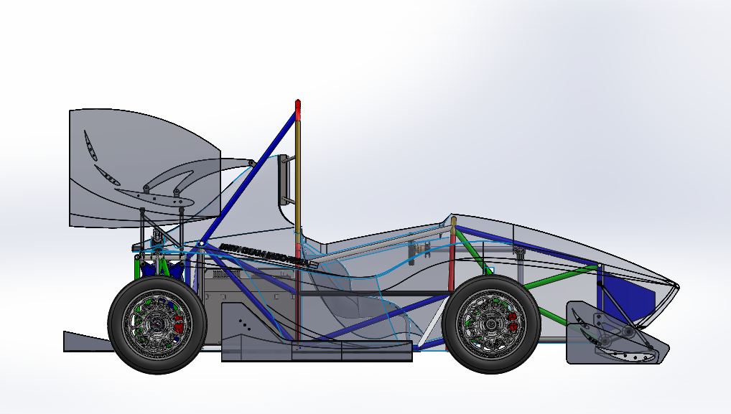

ESF Contact : AKHID SULTHONI

E-mail : [akhid.s27@gmail.com](mailto:akhid.s27@gmail.com)

# Sign of ESA



# Table of Content

Sign of ESA 2

Table of Content 3

Table of Figures 5

Table of Tables 6

Abbreviations 7

1 System Overview 8

2 Tractive System Schematics 9

2.1 Tractive System Schematic (Power Electronics ONLY) 9

2.2 Fusing Diagram 9

3 Shutdown Circuit 11

3.1 Shutdown Circuit Schematic 11

3.2 Wiring 14

3.3 IMD 14

3.4 Brake System Plausibility Device 16

3.5 Battery Management System 18

4 Safety Systems 24

4.1 TSAL 24

4.2 Measurement Points 25

4.3 HVD 27

4.4 Discharge Circuit 31

5 Accumulator 34

5.1 Accumulator Schematic 34

5.2 Cells 34

5.3 Segments 36

Amphenol Radlok / RL01001-50 36

5.4 Precharge Circuit 38

5.5 BMS 40

5.6 AIR 44

5.7 Accumulator Indicator 45

5.8 Mechanical 45

5.9 Charging 46

6 Motor Controller 48

6.1 Controls Architecture/Torque Security 48

6.2 Galvanic Isolation 48

7 Other Items 49

7.1 Energy Meter 49

7.2 Firewall 49

7.3 Grounding 50

7.4 Other Components 50

8 Appendix 51

8.1 Kokam SLPB78216216H 51

8.2 NYAF cable 70 mm2 53

8.3 MOTOR EMRAX 208 LC IP65 54

8.4 Model 6387 Banana Jack 55

8.5 IMD 56

8.6 Potentiometer 57

8.7 HVD 59

8.8 BMS 60

8.9 Fuse L50QS250 61

8.10 Buzzer SFM-27-I 62

8.11 Delay Relay H3Y-2 63

8.12 Thermistor 10K 65

8.13 Tyco EV200 Contactor 500AMP 320V 66

8.14 Firewall 68

8.15 Current Sensor (L06P400S05) 69

8.16 Precharge and Discharge Resistor 70

8.17 Resistor for TSMP 73

8.18 Charger 75

8.19 FUSE SMD 1 A PPTC 77

8.20 20 AWG & 22 AWG CABLE 78

8.21 Amphenol Radlok Connector 79

# Table of Figures

Figure 1‑1 - System Block Diagram 8

Figure 2‑1 - HV System Schematic 9

Figure 3‑1 - Shutdown Circuit Schematic 12

Figure 3‑2 - Shutdown Circuit Switch Locations 13

Figure 3‑3 - IMD Latch Circuit Schematic 15

Figure 3‑4 – IMD Location 16

Figure 3‑5 - BSPD Schematic 17

Figure 3‑6 - BSPD Component Location 17

Figure 3‑7 - BMS Latching Schematic 23

Figure 4‑1 - TSAL Circuit Schematic 24

Figure 4‑2 - TSAL Component Locations 25

Figure 4‑3 - Measurement Point Location 26

Figure 4‑4 - TSMP Protection Resistor Location 27

Figure 4‑5 - HVD Interlock 28

Figure 4‑6 - HVD Latching Schematic 29

Figure 4‑7 - HVD Location 30

Figure 4‑8 - HVD General Wiring 31

Figure 4‑9 - Discharge Circuit Component Locations 32

Figure 4‑10 - Discharge Circuit 32

Figure 5‑1 - Accumulator Schematic 34

Figure 5‑2 - Cell Connection Detail 35

Figure 5‑3 - Cell Mounting in Accumulator 36

Figure 5‑4 - Maintenance Plug Locations 37

Figure 5‑5 - Precharge Circuit Location 38

Figure 5‑6 - Location of Temperature Sensors 42

Figure 5‑7 - BMS Location 44

Figure 5‑8 - Schematic of Accumulator Indication 45

Figure 5‑9 - AIR and Fuse Separation 46

Figure 5‑10 - Charging Shutdown Circuit Schematic 47

Figure 5‑11 - Charging TS Schematic 47

Figure 6‑1 - Toque Control Signal Path 48

Figure 7‑1 - Energy Meter Location 49

Figure 7‑2 - Firewall Location 50

# Table of Tables

Table 1‑1 - High Level Specifications 8

Table 2‑1- Fuse Tree Diagram 9

Table 2‑2 - Fuse Specifications 9

Table 2‑3 - Conductor Specifications 10

Table 2‑4- Connector Specifications 10

Table 3‑1 - Shutdown Circuit Loads 14

Table 3‑2 - IMD Specifications 14

Table 3‑3 - BSPD Current Sensor Specifications 16

Table 3‑4 - BSPD Operation Details 16

Table 4‑1 - TSAL Specifications 24

Table 4‑2 - Measurement Point Specifications 25

Table 4‑3 - TSMP Protection Resistor Specifications 26

Table 4‑4 - HVD Specifications 27

Table 4‑6 - Discharge Resistor Specifications 31

Table 4‑7 - Discharge Relay Specifications 31

Table 5‑1 - Cell Specifications 35

Table 5‑2 - Segment Specifications 36

Table 5‑3 - Maintenance Plug Connector Specification 36

Table 5‑4 - Precharge Resistor Specifications 38

Table 5‑5 - Precharge Relay Specifications 38

Table 5‑6 - Temperature Sensor Specifications 41

Table 5‑7 - BMS Setpoints 43

Table 5‑8- AIR Specifications 44

Table 5‑9 - Charger Specifications 46

Table 7‑1 - Firewall Specifications 49

# Abbreviations

AIR – Accumulator Insulation Relay

AMS- Accumulator Monitoring System

BMS- Battery Monitoring System

BOTS – Brake-Over-Travel-Switch

BSPD – Brake System Plausibility Device

GLV – Grounded Low Voltage

GLVMP – Ground Low Voltage Measurement Point

HV – High Voltage

HVD – High Voltage Disconnect

IMD – Insulation Monitoring Device

TS – Tractive System

TSAL – Tractive System Active Light

TSMP – Tractive System Measurement Point

# System Overview

The electrical system is divided into two sub-system. The low voltage system is 12 VDC that powered by Lead Acid Battery and Accumulator 320 VDC, and the high voltage is 320 VDC max that only powered by Accumulator 320 VDC. And we use a BLDC Motor with that equipped with Motor controller 80kW.

|  |  |
| --- | --- |
| Maximum Tractive System Voltage: | 320VDC |
| Nominal Tractive System Voltage: | 281.2VDC |
| Grounded Low Voltage System Voltage: | 12VDC |
| Number of Accumulator Containers: | 1 |
| Total Accumulator Capacity: | 10kWh |
| Motor Type: | Axial flux synchronous permanent magnet motor/generator; sinusoidal three phase |
| Number of Motors: | 1 |
| Maximum Combined Motor Power: | 80kW |

Table ‑ - High Level Specifications

System overview block diagram showing major electrical components and system interactions 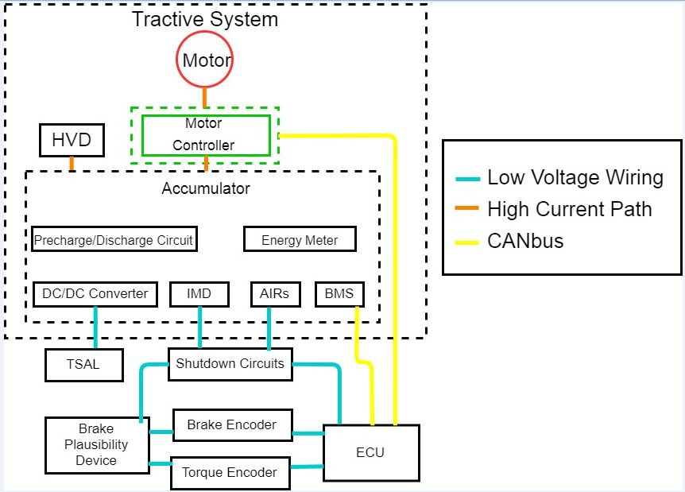

Figure ‑ - System Block Diagram

# Tractive System Schematics

## Tractive System Schematic (Power Electronics ONLY)

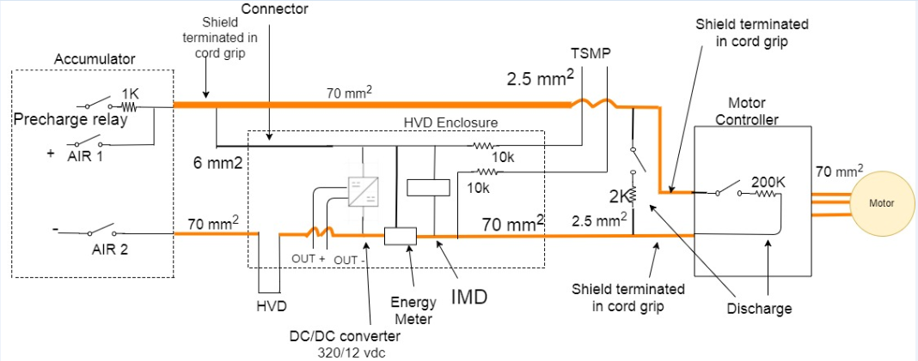

Figure ‑ - HV System Schematic

## Fusing Diagram

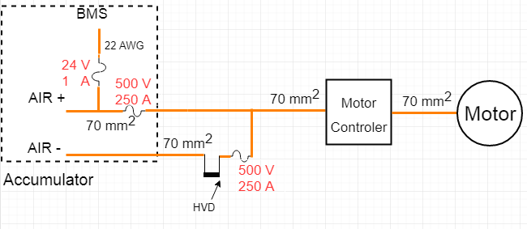

Table ‑- Fuse Tree Diagram

### Fuse Specifications

|  |  |  |  |  |
| --- | --- | --- | --- | --- |
| **Fuse Location** | **Current Rating** | **Voltage Rating** | **Interrupt Rating** | **Datasheet** |
| Shielded Copper Cable to HVD | 250 A | 500 V | 50 kA | Datasheet |
| PCB for voltage sense | 500mA | 24 V | 1 A | Datasheet |
| Pole positive to AIR (Tyco EV200) | 250 A | 500 V | 50 kA | Datasheet |

Table ‑ - Fuse Specifications

The Orion BMS has internal fuses on each of the positive cell tap wires.The Orion BMS has internal fuses on each of the positive cell tap wires. We use fuse between negative pole accumulator and HVD.

### Conductor Specifications

|  |  |  |  |  |  |
| --- | --- | --- | --- | --- | --- |
| **Conductor Location** | **Size** | **Voltage Rating** | **Ampacity** | **Rating of fuse providing protection** | **Datasheet** |
| Cell voltage taps to BMS | 22 AWG | 600 | 0.7 | 500 mA | Datasheet |
| Shielded Copper Cable Accumulator to Motor controller | 70 mm2 | 490 | 306 | 245 A | Datasheet |
| Pole positive to AIR (Tyco EV200) | 70 mm2 | 490 | 306 | 245 A | Datasheet |
| Shielded Copper Cable to HVD | 70 mm2 | 490 | 306 | 245 A | Datasheet |

Table ‑ - Conductor Specifications

### Connector Specifications

|  |  |  |  |  |  |
| --- | --- | --- | --- | --- | --- |
| **Connector Location** | **Ampacity** | **Voltage Rating** | **Includes Interlock** | **Accepted wire gauge** | **Wire gauge connected** |
| MOTOR CONTROLLER | 250 | 600 V | Nc | 70 mm2 | 70 mm2 |
| HVD | 630 | 450 V | NC | 70 mm2 | 70 mm2 |
| MOTOR CONTROLLER TO MOTOR | 250 | 600 V | NC | 70 mm2 | 70 mm2 |
| BMS TO TAP VOLTAGE | 0.5 | 12 V | NC | 22 AWG | 22 AWG |
| IMD | 2 | 12 V | NC | 20 AWG | 20 AWG |

Table ‑- Connector Specifications

# Shutdown Circuit

## Shutdown Circuit Schematic

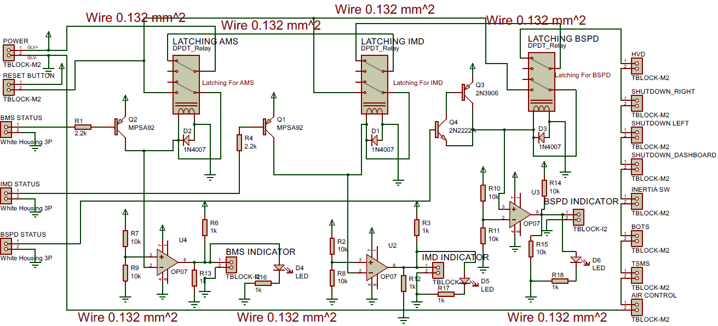

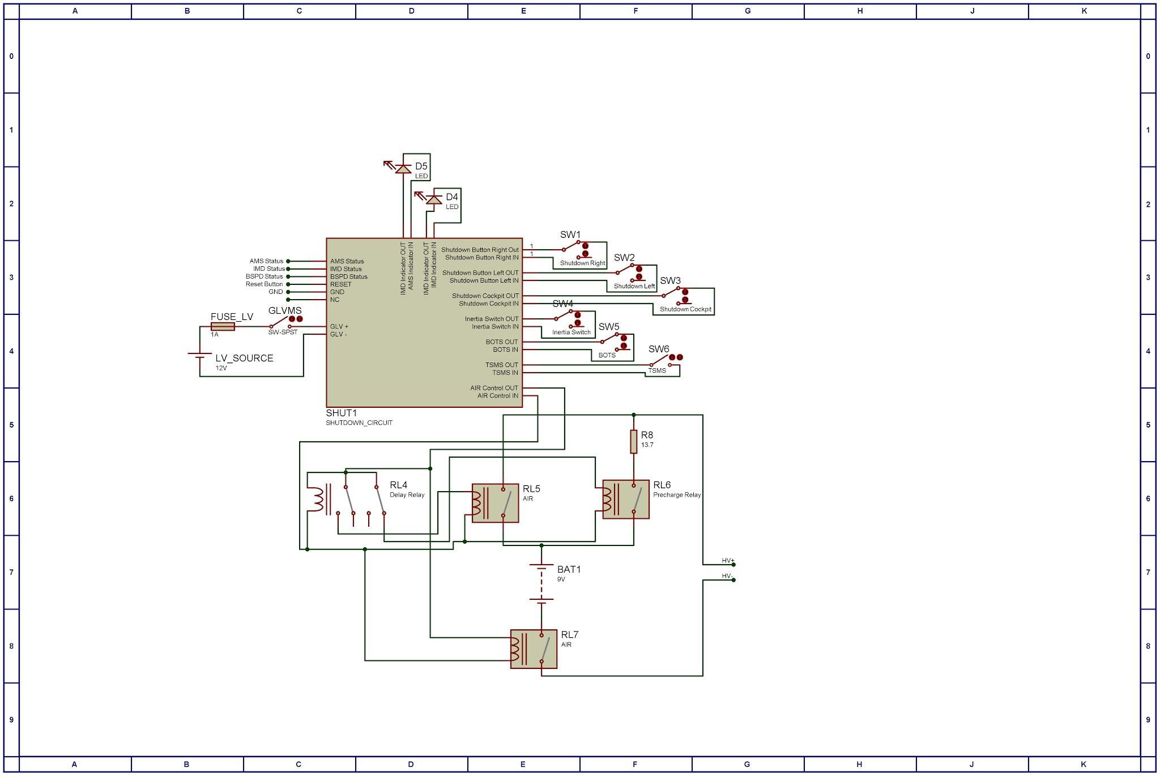

Figure ‑ - Shutdown Circuit Schematic

### Switch Locations

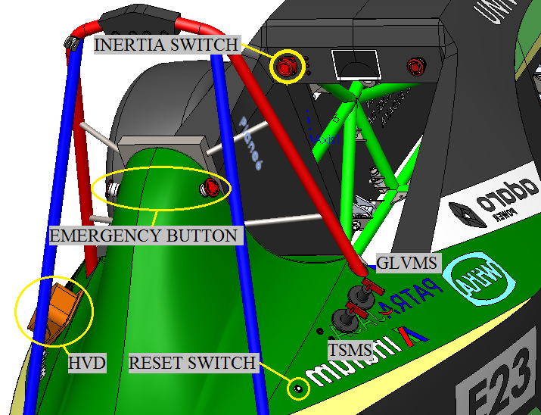

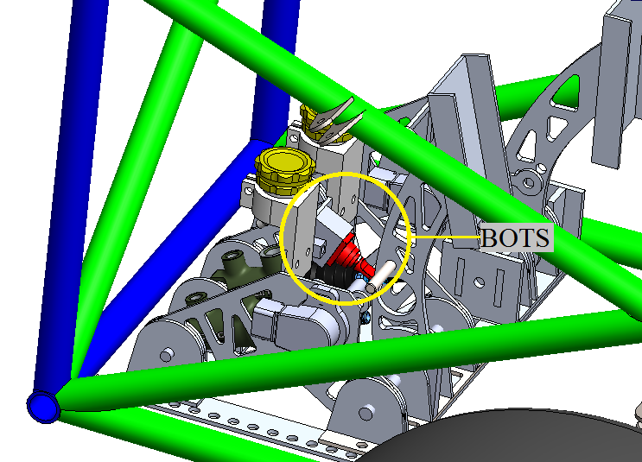

Figure ‑ - Shutdown Circuit Switch Locations

## Wiring

### Shutdown Circuit Current

|  |  |
| --- | --- |
| Total Number of AIRs: | 2 |
| Current per AIR: | 0.5A |
| Additional parts consumption within the shutdown circuit: | 2A |
| Total current: | 3A |

Table ‑ - Shutdown Circuit Loads

## IMD

### IMD Specifications

|  |  |
| --- | --- |
| Make / Model | Bender IR155 |
| Supply voltage | 12 VDC |
| Environmental temperature range: | -40 … +105°C |
| Self-test interval: | after power on and every 5 minute |
| High voltage range: | DC 0..800V |
| Set response value: | 200kΩ (500Ω/Volt) |
| Max. operation current: | 150mA |
| Approximate time to shut down at 50% of the response value: | 5s |
| Datasheet | Datasheet |

Table ‑ - IMD Specifications

### IMD Fault Latching

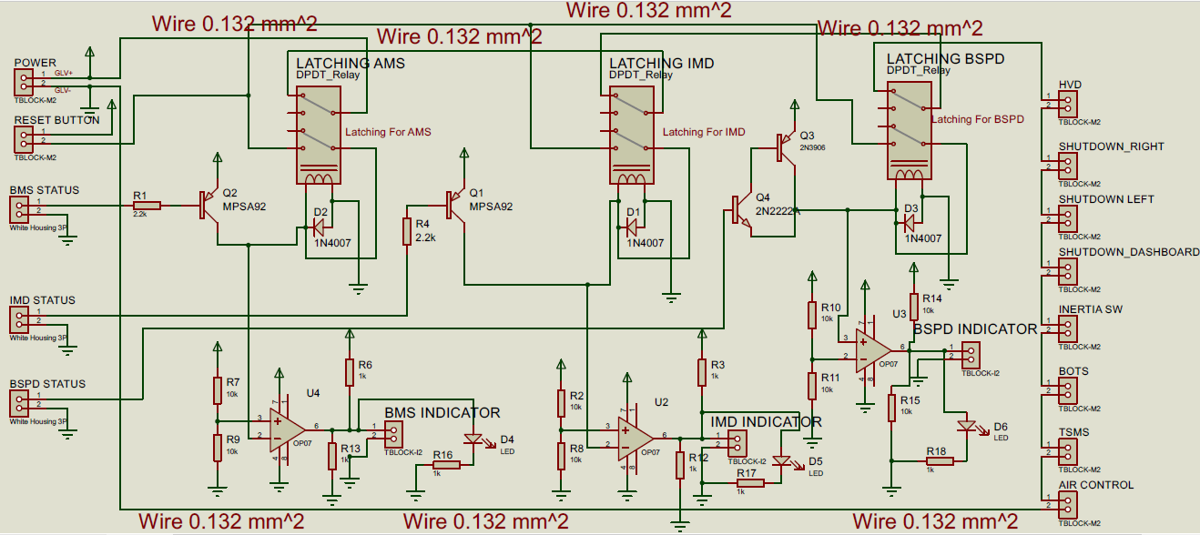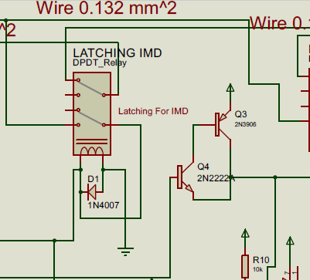

Figure ‑ - IMD Latch Circuit Schematic

### IMD Location

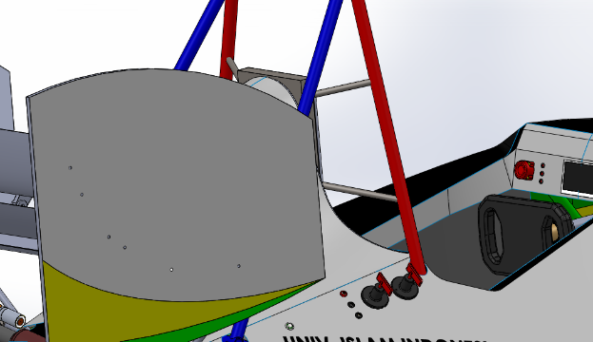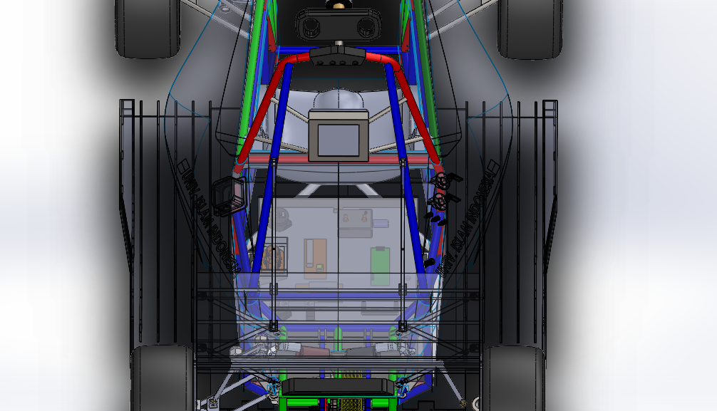

**IMD LOCATION**

**RESET SWITCH**

**IMD INDICATOR**

Figure ‑ – IMD Location

### IMD Demonstration

The IMD device used is the BENDER IR155-3204. This IMD measure resistance between the GLV and HV system. HV from the system has 320 Volt, therefore EV has set response with value 80k ohm.

1. Normally IMD is Active High, that state indicate no fault from IMD
2. For EV inspection, We use Potentiometer to set resistor to 80k ohm.
3. So if fault detected, then Output from pin OKHS is going to be Activate low
4. And from NOT gate that build by transistor is going to activate relay Latching and hold the state until reset button is pressed

## Brake System Plausibility Device

### BSPD Current Sensor

|  |  |
| --- | --- |
| Make / Model: | Hall Effect Sensor/ L06P400S05 |
| Current input range: | +/- 500A |
| Output range: | 0.26-4.76 V |
| Datasheet: | [Datasheet](#_Current_Sensor_(L06P400S05)) |

Table ‑ - BSPD Current Sensor Specifications

### BSPD Setpoint

|  |  |
| --- | --- |
| Trip Current | 15A |
| Current sensor output @Trip Current | 320V |
| Delay time | 500ms |

Table ‑ - BSPD Operation Details

### BSPD Schematic

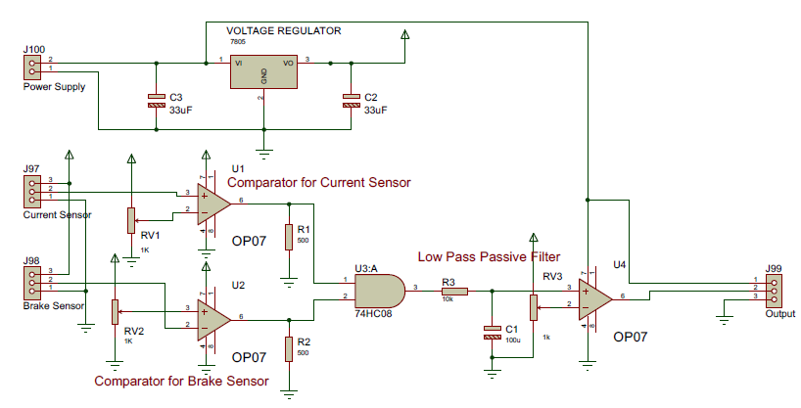

Figure ‑ - BSPD Schematic

### BSPD Location

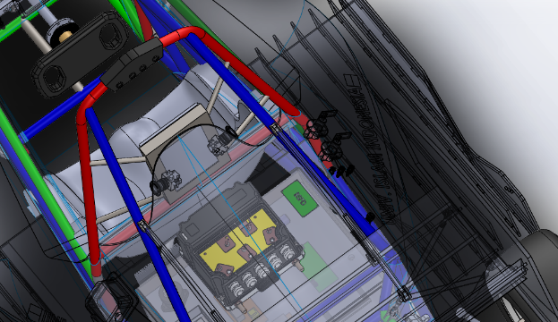

BSPD LOCATION

Figure ‑ - BSPD Component Location

### BSPD Demonstration

BSPD is a standalone non-programmable circuit that would open AIRs when positive current flow from accumulator to motor controller that has power more than 5kW and Hard Braking is detected for more than 0.5s. This Plausbilllity is latcther until reset button pressed.

Our BSPD Circuit has 2 comparator that compare current value with threshold that set by potentio. This threshold are going to be achieve if postive current flow from Accumulator to Motor controller has power more than 5kW or current that flow from battery to Motor Controller is more than 15A(This current is selected because we use battery that has voltage 320 volt) that indicate that our current sensor . And another comparator compare brake pressure with threshold that was set by others potentio. The comparators are going to deliver 5 voltage if both comparator got threshold value.

The results from 2 comparatore above are going to be input for AND gate. The Plausbillity was detected if both comparators are on high level for more than 0.5s. Therefore the output of AND gate is connected to low pass filter.

Than BSPD latching is located inside Circuit Shutdown, view in figure .. Latching Circuit has 2 relay that is going to latch Plausibillity state untuk button reset is pressed.

## Battery Management System

### BMS Faults

**Error signal output (default)** - In the event that any fault code is present on the BMS or in the event that both CHARGE and READY power are present to the BMS at the same time, this output will turn on. It can be used to drive an LED, buzzer or other device (additional components may be required, see the wiring manual for details). The basic analog display module makes use of this multi-purpose output function. Fault Code on the BMS to tridder Error signal output is written below :

1. **Wiring Fault Error Code** - This error code indicates that the BMS has determined that a cell tap wire is either weakly connected or not connected and as a result, it has determined that it cannot accurately measure cell voltages. Wiring faults can be caused by improperly wired cell taps, loose cell tap connection, cell taps that are not connected to the battery, internal fuses blown inside the BMS or other internal damage to the BMS from previous improper wiring.
2. **Internal Communication Fault** - This error indicates that the Orion BMS has encountered an error trying to communicate with the isolated circuitry that measure cell tap voltages. This error can be caused by external electrical noise if the BMS is not properly grounded or by an internal hardware failure.
3. **Pack Voltage Mismatch Error** - This error code indicates that the voltage measured by the total pack voltage sensor did not match the sum of the individual cell voltage measurements. This error is triggered when the difference in voltage between the two measurements exceeds the ‘Pack Voltage Mismatch Threshold’ setting in the BMS profile (under Pack Settings).
4. **Current Sensor Fault** - A current sensor fault is triggered if the analog voltages from the attached current sensor stray outside of the normal range or if the values from the 2 redundant current sensors do not match. The current sensor may be sized incorrectly, the wiring harness may be faulty or the BMS or current sensor may be faulty.  
   This error code will cause the BMS to enter a current sensor failsafe mode. The BMS is fully able to protect the cells in this mode and therefore the BMS will continue to operate in a voltage based mode. In this failsafe mode the BMS will continue to operate and protect the cells. However, some calculations are unavailable and many features are disabled or degraded such as state-of-charge calculation, open cell voltage calculation, and discharge and charge limit amperages are calculated using a backup algorithm. Please see the operational manual for more detailed information on what is and what is not available in this mode.
5. **Weak Cell Fault** - This fault is triggered based on thresholds programmed into the BMS profile that indicate when a cell is “weak”. While this error code is designed to indicate a cell is weak, this error is triggered when certain pre-programmed conditions are met and does not necessarily indicate a dead cell because it can also be triggered by loose busbars, other wiring issues or incorrect error threshold settings in the profile.
6. **Internal Logic Fault Code** - This error code indicates that the Orion BMS has determined that an internal hardware fault has occurred. If this error message occurs, please download the associated freeze frame data and contact the factory or authorized dealer for assistance. Please save the freeze frame data and send it along with any other relevant information to the factor as it may be crucial for appropriately repairing the unit.
7. **Internal Conversion Fault** - This error code indicates that the Orion BMS has determined that an internal hardware fault has occurred. If this error message occurs, please download the associated freeze frame data and contact the factory or authorized dealer for assistance. Please save the freeze frame data and send it along with any other relevant information to the factor as it may be crucial for appropriately repairing the unit.
8. **Low Cell Voltage Fault** - This fault code is triggered when the voltage of a cell falls below 0.09 volts (90 mV). This fault can be caused by a cell that is incorrectly set in the BMS profile as a “populated” cell, a disconnected cell wiring harness, a very dead cell, or a wiring error. In a revision E unit, this fault code can also indicate two or more cell voltage tap wires are backwards. If cell voltage tap wires are backwards, the cell voltage tap connectors should be immediately disconnected from the BMS unit until the issue is corrected as permanent damage may occur to the unit and may drain the attached cells damaging them.
9. **High Voltage Isolation Fault -** This code is set when the BMS measures an isolation breakdown between the high voltage battery and the 12 volt system. A breakdown in isolation can be caused by ruptured or leaking cells, high voltage cabling insulation that has rubbed off and come into contact with low voltage systems, condensation, use of non-isolated equipment, by an intentionally non-isolated design, or by other causes. This error code may indicate an unsafe condition that exists in the battery pack and care must be taken to avoid risk of short circuit and risk of personal injury from shock while investigating the error as simply touching a cell could cause a shock. While this error tends to indicate a real problem, there are certain situations that can cause a false positive.
10. **Pack Voltage Sensor Fault** - This fault code is set if the total pack voltage sensor reads zero volts. This error will also cause a volt age redundancy fault code. This fault code may be the result of the voltage tap connection not being connected when the BMS was turned on, a wiring error on the total pack voltage sensor, a voltage tap that is wired to the wrong location or an internal BMS error.
11. **Weak Pack Fault** - This error code is designed to alert a user to if the battery pack has degraded and is weak, this error is triggered based only when pre-programmed conditions are met and does not necessarily indicate a weak is actually weak since the error threshold may be set wrong. This error may be falsely triggered by incorrect profile settings, a battery pack with an abnormally low state-of-charge or by malfunctioning thermistors which are not accurately reading the pack temperature.
12. **Fan Monitor Fault** - This fault is triggered when the BMS requests the external fan and the voltage measured at the fan monitor pin on the BMS is below (or above if inverted) the error threshold programmed into the profile. This is used strictly for monitoring performance of an external fan and alerting a user to a fan fault. This is only used if external monitoring of a fan is needed.
13. **CANBUS Communication Fault** - This fault means the BMS did not receive a CANBUS message it was expecting. The fault is only enabled under 2 conditions:

Condition 1) If the BMS is specifically configured to monitor for the presence of external CAN message (heartbeat monitoring).

Condition 2) If multiple BMS units are strung together in series (maste-slave mode) and communication is lost between 2 units.

This error is set if communication messages are not received after a specified amount of time. This error is most commonly caused by incorrect profile settings (i.e. a unit setup for master slave configuration when it is not actually in a master slave configuration), if the BMS and the other device are powered up or down at slightly different times (not powered by the same power rail) or if the CANBUS is not properly terminated.

1. **Redundant Power Supply Fault** - This error message is triggered when the always on power to the BMS is off while the READY or CHARGE power is on. This error is not triggered on revision D & newer units if “Disable Always On Power Supply” setting is on since revision D & newer units do not require always on power for storing data.
2. **12v Power Supply Fault** - This fault is triggered when the voltage measured by the BMS drops below approximately 9v for 5 to 8 seconds. This code remains set even after the voltage has returned to normal.
3. **Charge Limit Enforcement Fault** - These 3 fault codes are caused when charge or discharge current (respectively) either exceeds the limit set by the BMS or continues after the digital on/off outputs are turned off. For example, if the BMS has set a discharge current limit (DCL) of 50 amps and the BMS measures 100 amps for an amount of time exceeding the limit in the profile, it will set the discharge limit enforcement fault since more current is being drawn than is allowed. The same fault will get set if the BMS turns off the discharge enable output and any current is discharged after the set amount of time passes. Charge limit enforcement corresponds to charge current; discharge limit enforcement corresponds to discharge current. *This error can be falsely triggered if the current sensor polarity is backwards.*   
   When this error is triggered, the BMS is put into a failsafe mode and all 3 charge / discharge / charger enable outputs are turned off in the event the outputs are wired backwards. The failsafe condition will reset when power is cycled.
4. **Thermistor Fault -** A thermistor fault is triggered detected if the analog voltage measured from the thermistor is outside of the normal thermal operating range. This error can be triggered if the temperature of the thermistor rises above 81C or drops lower than -41C. A shorted or open wire can result in artificially high or low measurements that would result in this error code. The use of an incompatible thermistor can cause inaccurate readings and trigger this error code.

When this error code is set, the Orion BMS will disregard the value of the affected thermistor, using the values of the other thermistors and continue to operate normally.

1. **Discharge Limit Enforcement Fault** - These 3 fault codes are caused when charge or discharge current (respectively) either exceeds the limit set by the BMS or continues after the digital on/off outputs are turned off. For example, if the BMS has set a discharge current limit (DCL) of 50 amps and the BMS measures 100 amps for an amount of time exceeding the limit in the profile, it will set the discharge limit enforcement fault since more current is being drawn than is allowed. The same fault will get set if the BMS turns off the discharge enable output and any current is discharged after the set amount of time passes. Charge limit enforcement corresponds to charge current; discharge limit enforcement corresponds to discharge current. This error can be falsely triggered if the current sensor polarity is backwards.  
   When this error is triggered, the BMS is put into a failsafe mode and all 3 charge / discharge / charger enable outputs are turned off in the event the outputs are wired backwards. The failsafe condition will reset when power is cycled.
2. **Charger Safety Relay Fault -** These 3 fault codes are caused when charge or discharge current (respectively) either exceeds the limit set by the BMS or continues after the digital on/off outputs are turned off. For example, if the BMS has set a discharge current limit (DCL) of 50 amps and the BMS measures 100 amps for an amount of time exceeding the limit in the profile, it will set the discharge limit enforcement fault since more current is being drawn than is allowed. The same fault will get set if the BMS turns off the discharge enable output and any current is discharged after the set amount of time passes. Charge limit enforcement corresponds to charge current; discharge limit enforcement corresponds to discharge current. This error can be falsely triggered if the current sensor polarity is backwards.   
   When this error is triggered, the BMS is put into a failsafe mode and all 3 charge / discharge / charger enable outputs are turned off in the event the outputs are wired backwards. The failsafe condition will reset when power is cycled.
3. **CANBUS Controlled output** - When this option is selected, the status of this output is controlled by a CANBUS message. Note: Additional CANBUS configuration is needed and this should not be relied on for safety operations such as enabling charge or discharge.
4. **Low SOC output** - This output will turn on whenever the state of charge drops below the SOC output threshold. This output will turn back off once it rises above the turn-off condition. The difference between the two voltages provides hysteresis to prevent rapid oscillations.
5. **Low Temperature Output** - This feature will turn on the output whenever the lowest temperature (either from the 4 integrated thermistors or from an external thermistor expansion module if configured) drops below the low temperature threshold. This output will turn back off once the lowest temperature rises above the hysteresis value.
6. **Charge Interlock Output** - This option will cause the multipurpose output to turn on in the event that the BMS detect both CHARGE and READY power at the same time. While powering CHARGE and READY power at the same time poses no problem for the BMS, sometimes it is desirable to inhibit driving via an external means when this happens.
7. **High Cell Voltage Output** - This option will turn the multipurpose output on if the highest cell in the pack reaches the high cell voltage threshold. The output will turn off when all cells have fallen back down below the hysteresis value. Note: This output is not designed to be the primary control for discharge or charge. The output will not turn off in the event of a critical fault, overtemperature, or other safety condition! Use the charge enable, discharge enable, charger safety or CANBUS for primary control of charge and discharge.
8. **Low Cell Voltage Output** - This option will turn the multipurpose output on if the lowest cell in the pack drops below the threshold. The output will turn off when all cells have risen above the hysteresis threshold. Note: This output is not designed to be the primary control for discharge or charge. The output will not turn off in the event of a critical fault, over temperature or other safety condition! Use the charge enable, discharge enable, charger safety or CANBUS for primary control of charge and discharge.
9. **Low DCL Output** - This option will cause the multipurpose output to turn on in the event that the calculated discharge current limit from the BMS falls below the threshold. The output will turn off when it rises again above the pre-defined amount.
10. **Low CCL Output** - This option will turn the multipurpose output on in the event that the calculated charge current limit from the BMS falls below the threshold. The output will turn off when it rises again above the pre-defined amount.

### BMS Fault Latching





Figure ‑-BMS Latching Schematic

Our BMS latching only using DPDT relay that can latch when BMS has detected fault, and reset when Reset button is pressed. BMS status indicate by BMS indicator that located on dashboard.

### BMS Demonstration

BMS Device used is OrionBMS. If No Fault was detected, BMS digital output is activate high. And The BMS indicator in cockpit is turn on and Circuit shutdown is close. And The Tractive System could be ready. If BMS detect Fault, BMS is going to open drain the output and the mosfet and relay switch on and latch state.

# Safety Systems

## TSAL

### TSAL Specifications

|  |  |
| --- | --- |
| Make/Model: | High Power LED |
| Color: | RED indicated Tractive System ON |
| Flash Rate: | 3Hz |
| Powered By: | GLV |
| Controlled By: | Tractive System have Isolated DC-DC converter that can used as supply for TSAL. We used that DC-DC output that triggered by HV because the DC-DC are directly connected through the Tractive. The DC-DC Converter only on when HV get input from 180V to 375V |
| TS Turn On Voltage: | 60 |
| TS Turn Off Voltage: | 58 |

Table ‑ - TSAL Specifications

### TSAL Schematic

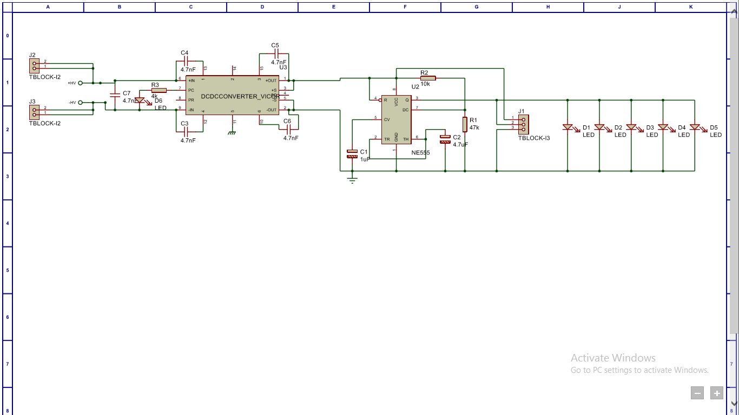

Figure ‑ - TSAL Circuit Schematic

### TSAL Location

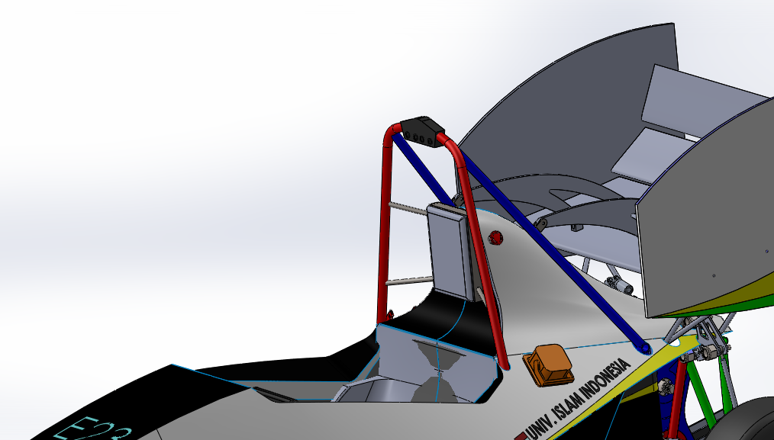

TSAL

Figure ‑ - TSAL Component Locations

## Measurement Points

### Measurement Point Specifications

|  |  |
| --- | --- |
| Make / Model: | Pomona Electronics Model 6387 |
| Voltage Rating: | 1000V |
| Datasheet: | Datasheet |

Table ‑ - Measurement Point Specifications

### Measurement Point Location

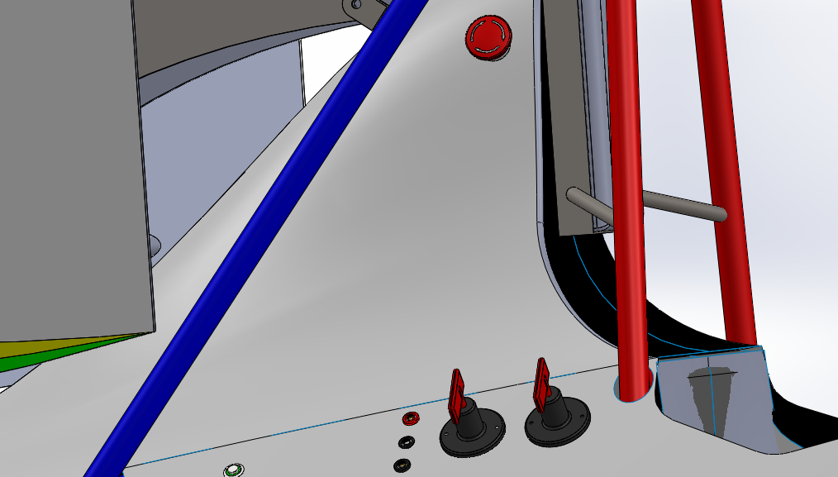

Tractive

Measurement Point

GLV

Measurement Point

Figure ‑ - Measurement Point Location

### Measurement Point Protection

When Electrical Inspection the front of the TSMP will be covered with a cap and the material will be made with 3D print. The cap designed to be easy to put and take but still it can protect the jack from water to get inside. Back of the TSMP will be glued or sealed with tube so the water can’t get inside from the banana jack surface.

### TSMP Protection Resistor

|  |  |
| --- | --- |
| Make / Model: | Resistor |
| Resistance: | 10,000Ω |
| Voltage Rating: | 320V |
| Power Rating: | 5W |
| Datasheet: | Datasheet |

Table ‑ - TSMP Protection Resistor Specifications

### TSMP Protection Resistor Location

The resistor will be mounted to the pomona banana jack with 3D printed housing like this picture below.

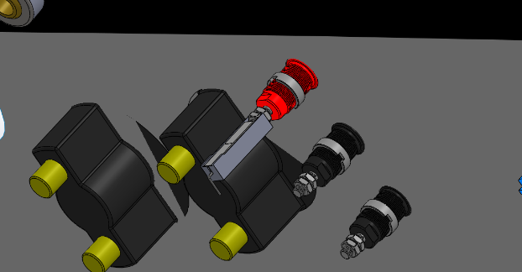

Figure ‑ - TSMP Protection Resistor Location

### TSMP Demonstration

1. Switch the GLVMS to close the GLV circuit and this step is indicated green LED by TSAL
2. Open the Cap of TSMP
3. Begin to measure Discharge Resistance value, and Current Limit Resistor Value, and TS voltage when Vehicle is off
4. Switch TSMS to close the TS circuit and this step is indicated red LED by TSAL
5. Begin to measure TS voltage when Vehicle is turn on
6. After all TSMP has been measured, switch TSMS to open TS circuit then switch GLVMS to open GLV circuit
7. Close the cap of TSMP

## HVD

### HVD Specifications

|  |  |
| --- | --- |
| Make / Model: | AMP+ Manual Service Disconnect |
| Ampacity: | 350A |
| Voltage rating: | 700VDC |
| Datasheet: | Datasheet |

Table ‑ - HVD Specifications

We use circuit external that connecting with HVD. So when HVD is open that interlock will be active.

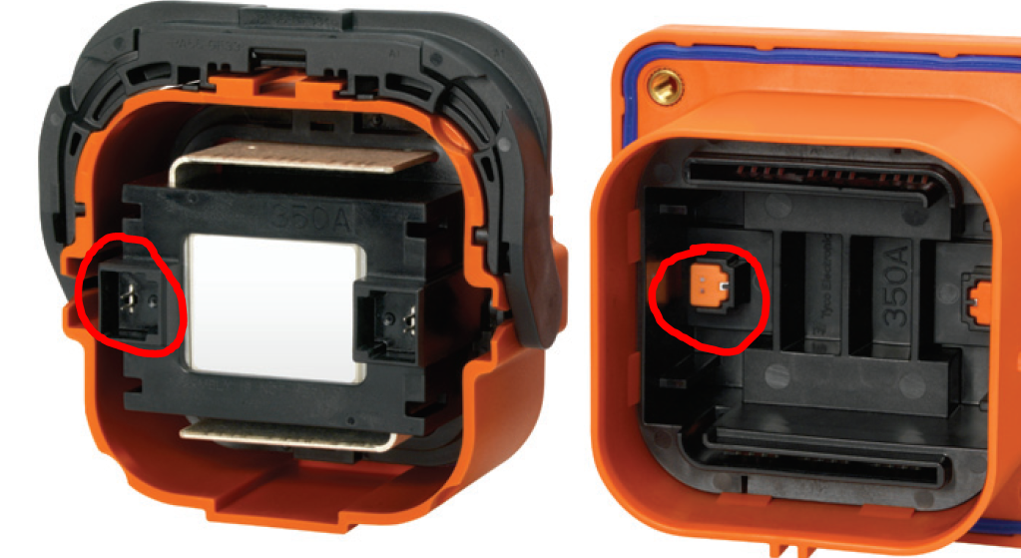

Figure ‑ - HVD Interlock

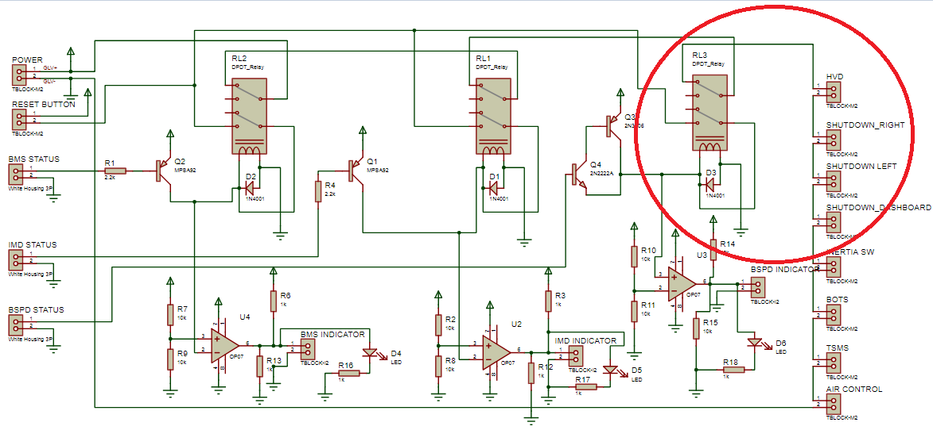

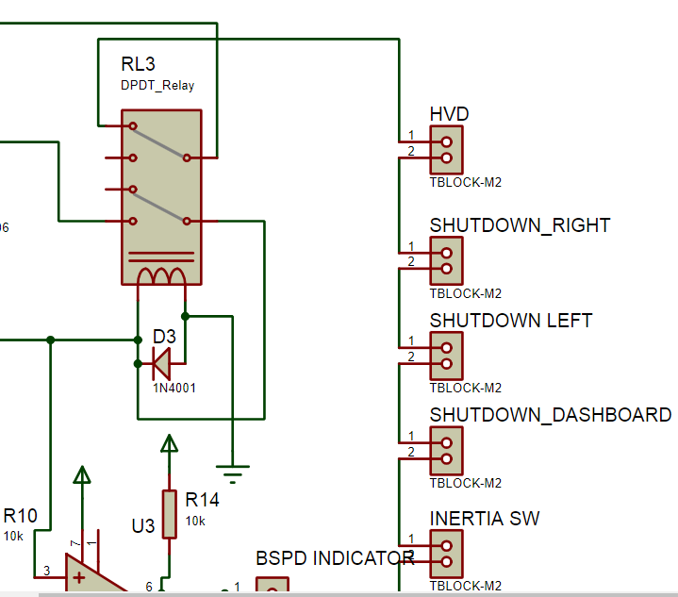

Figure ‑ - HVD Latching Schematic

### HVD Location

Our HVD are 635.21mm above the ground or similar to 63.521cm.

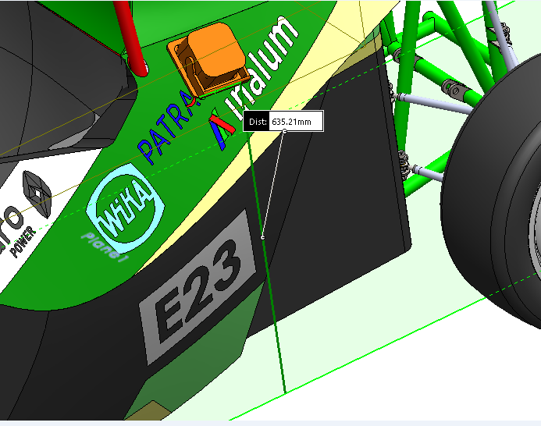

Figure ‑ - HVD Location

### HVD Connections

HVD will be mounted with a non-conductive handle attached directly to the plug. in order to protect the HVD from the rain, HVD will be given glue gunfire on the partition. The HVD using 70 mm2 cable that hold up to 220 degrees farenheit and rating up to 600V.

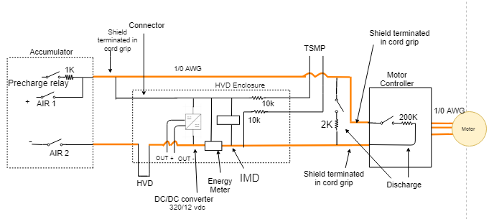

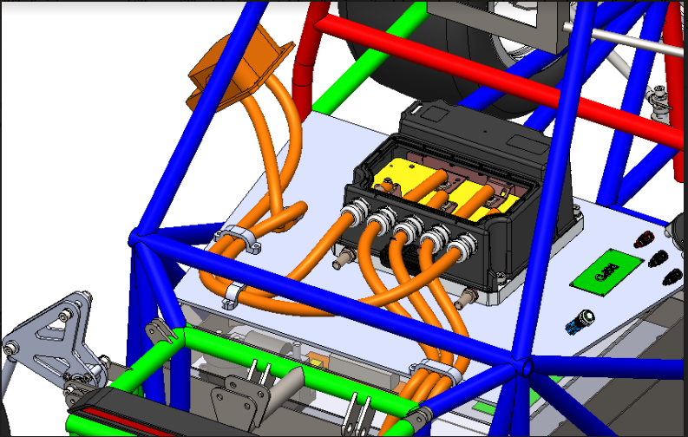

Figure ‑ - HVD General Wiring

### HVD Demonstration

The main HV connector will be installed in the rear of the car above the body where the accumulator is located. HVD is installed at 350 mm above ground level for easy viewing. If HVD is removed, then the system must shut down the tractive system and open the AIRs. HVD can be removed with no more than 10 seconds. HVD is also given a “HVD” mark and to Open, use Safety glove.

## Discharge Circuit

### Discharge Circuit Component Specifications

|  |  |
| --- | --- |
| Make / Model: | Liwang / RX27-4-30 |
| Resistance: | 2KΩ |
| Voltage: | 1000V |
| Power: | 30W |
| Power @15sec: | 80W |
| Datasheet | Datasheet |

Table ‑ - Discharge Resistor Specifications

|  |  |
| --- | --- |
| Make / Model: | Tyco EV200 Contactor 500AMP 320V |
| Contact Current Rating: | 500 A |
| Contact Voltage Rating: | 320V |
| Datasheet: | Datasheet |

Table ‑ - Discharge Relay Specifications

### Discharge Circuit Location

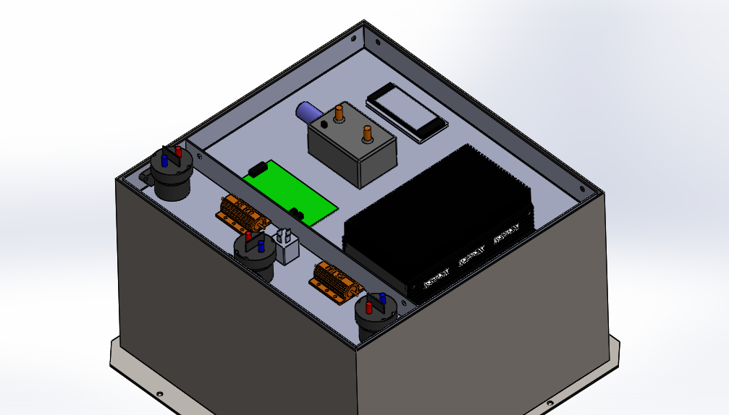

Figure ‑ - Discharge Circuit Component Locations

### Discharge Circuit Control

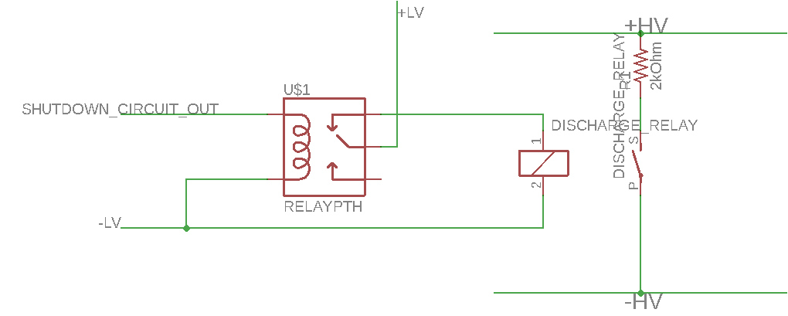

Figure ‑ - Discharge Circuit

Discharge Relay is closed when AIRs Closed or shutdown circuit open. Shutdown circuit output that parallel with Precharge is used to trigger relay to close Discharge Circuit. Schematic Discharge circuit is displayed above. Discharge will take not more than 5 seconds to make bus capacitance bus, the decrease of voltage is displayed below

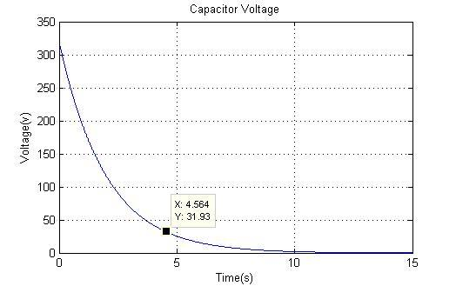

### Discharge Circuit Demonstration

1. When Shutdown Circuit closed, Discharge relay will open.
2. When Shutdown circuit Open, Discharge relay triggered and would close and going to discharge bus capacitance
3. Discharge will take not more than 5 second to make bus capacitance < 60VDC

# Accumulator

## Accumulator Schematic

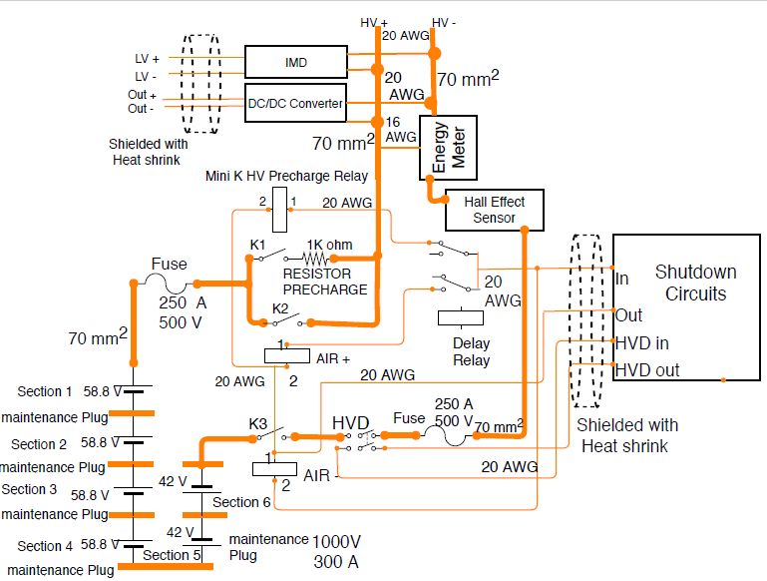

Figure ‑ - Accumulator Schematic

## Cells

### Cell Specifications

|  |  |
| --- | --- |
| Cell Make / Model / Style: | KOKAM / SLPB78216216H / Pouch |
| Cell nominal capacity: | 31.8 Ah |
| Maximum Voltage: | 3.609 V |
| Nominal Voltage: | 3.601 V |
| Minimum Voltage: | 4.2 V |
| Maximum output current: | 422 A for 10s |
| Maximum continuous output current: | 187.5 A |
| Maximum charging current: | 15 A |
| Maximum Cell Temperature (discharging) | 75°C |
| Maximum Cell Temperature (charging) | 85°C |
| Cell chemistry: | HP NMC |

Table ‑ - Cell Specifications

### Cell Electrical Configuration

The accumulator system consists of 76 battery cells with 76 cells connected in series. This packaging consists of a UL 94 V-0 rated internal fusing , built-in temperature sensing, and 9.5mm threaded high voltage path connections. there is 10 segments are then connected in series via copper busbar and connector Socket Anderson 350A**.** The busbar connecting the submodules will be attached via the 3mm bolts.

### Cell Connections

The cell is connected by serial link, on the cathode side and the anode will be folded then overlapped with copper plate. Then at the end of the plate will be on the bolt to strengthen its structure. Then between the parts on the cathode side and the anode will be skun with the cable and the cable connected by SB 350 connectors.

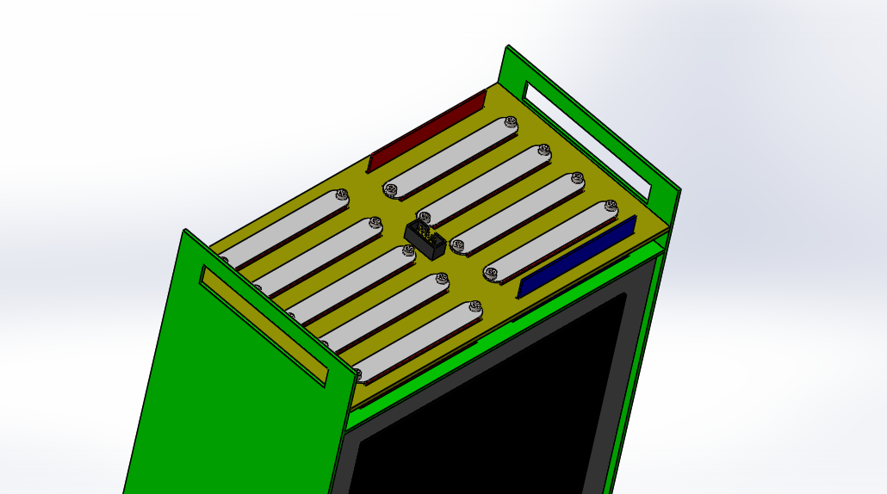

Figure ‑ - Cell Connection Detail

### Parallel Cell Overcurrent Protection

we’re not using parallel connection.

### Cell Mounting

Battery in pairs by inserting the batteries one by one to the hammered aklirik, then plug it into punched PCB in accordance with the number of batteries. If the two polar kutusuk have passed through the hole then the positive and negative poles of 2 different cells in bend until overlap. After that it is overwritten with a copper rod and bolts at both ends to strengthen the connection. Then make a series connection on the segment. To connect between parts using 70 mm2 copper cable and radlok amphenol connector. This process is repeated continuously so that 76 series series are connected.

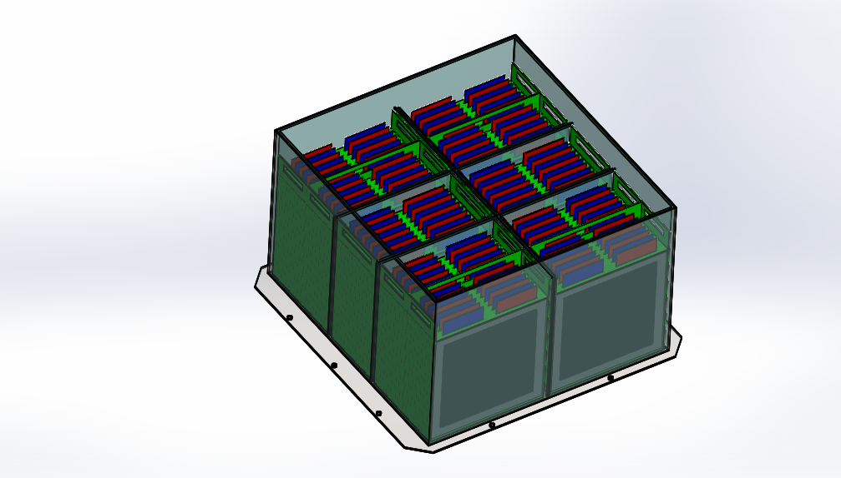

Figure ‑ - Cell Mounting in Accumulator

## Segments

### Segment Specifications

|  |  |
| --- | --- |
| # of Segments: | 10 |
| Cells per segment: | 7 & 10 |
| Cell configuration in segment: | 7S & 10S |
| Energy in segment: | 3.36MJ & 4.8 MJ / 0.93 kWhr & 1.33 kWhr |
| Datasheet: | Datasheet |

Table ‑ - Segment Specifications

### Segment Physical Isolation

The segment were isolated with acrylic, kapton tape and firewall isolation with 4mm thickness that separated between one segment to another. We used Anderson SB350 socket for the connection beetwen one segment to another.

### Maintenance Plugs

|  |  |
| --- | --- |
| Make / Model: | Amphenol Radlok / RL01001-50 |
| Ampacity: | 300A |
| Voltage: | 1000V |
| Datasheet: | Datasheet |

Table ‑ - Maintenance Plug Connector Specification

Maintenance plugs located in the anode and katode

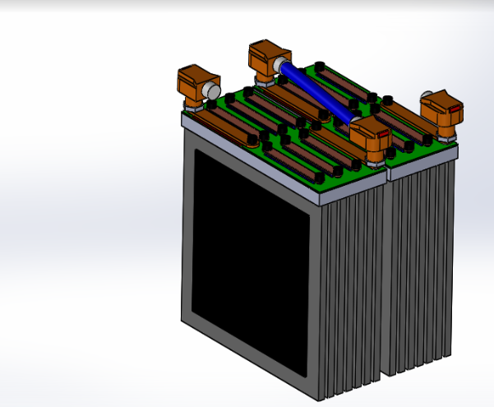

Figure ‑ - Maintenance Plug Locations

### Maintenance Plug Positive Locking

Maintenance plugs use with radlok amphenol connector. this connector have part which at the end has a hollow in the male connector. on the female part has a lock which when inserted male connector will lock the basin so it will not happen loose. To open a positive locking. on the female connector just press the top of his to open the lock.

### Maintenance Plug Unique Configuration

The design of the socket we use makes the mistake of installing the maintenace plug to be very small. This is because the socket can only be connected if the position of each socket is in the correct position. If the position of the socket is wrong, the socket can not be installed.

### Maintenance Plug Demonstration

steps:

1. use gloves according to the standard
2. use glasses according to standard
3. drag one of the sockets to the mate slowly
4. finish

PPE required:

1. Gloves
2. Glasses

## Precharge Circuit

### Precharge Circuit Component Specifications

|  |  |
| --- | --- |
| Make / Model: | Liwang / RX27-4-30 |
| Resistance: | 1000Ω |
| Voltage: | 320V |
| Power: | 30W |
| Power @15sec: | 450W |
| Datasheet | Datasheet |

Table ‑ - Precharge Resistor Specifications

|  |  |
| --- | --- |
| Make / Model: | Tyco EV200 Contactor 500AMP 320V |
| Contact Current Rating: | 500 A |
| Contact Voltage Rating: | 320V |
| Datasheet: | Datasheet |

Table ‑ - Precharge Relay Specifications

### Precharge Circuit Location

Precharge circuit is located in accumulator.

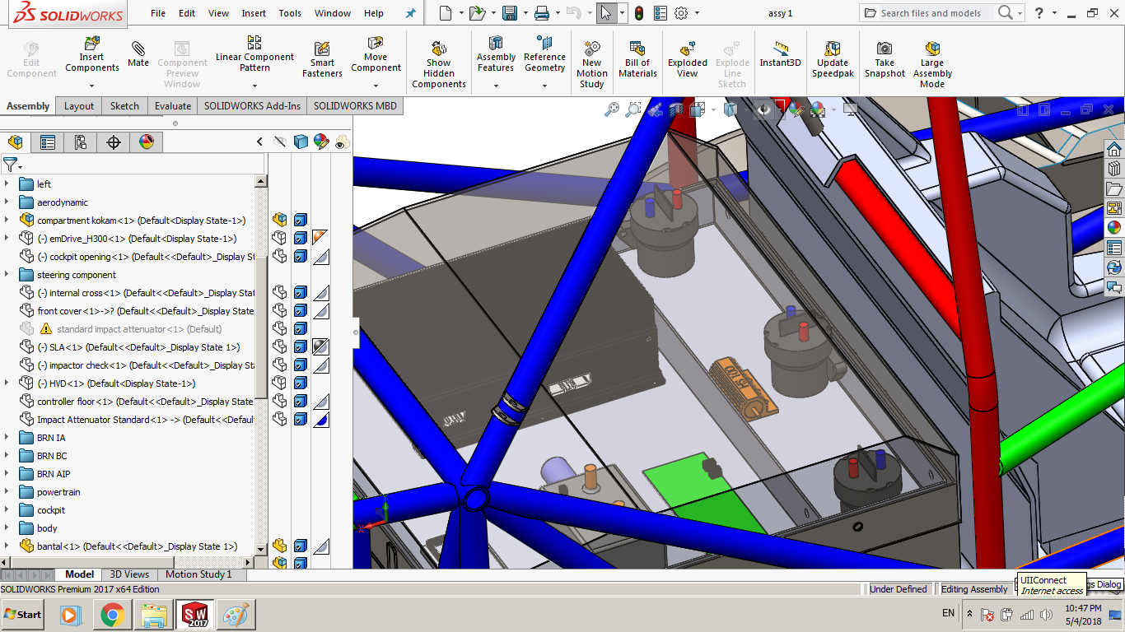

Figure ‑ - Precharge Circuit Location

### Precharge Circuit Controls

Pre-charging of internal capacitors in motor controllers input circuit to 90-95% of battery voltage is important to avoid inrush and pitting of contactors. Our motor controller has internal capacitor that the value is 1 mF. Our precharge circuit following the schematic below

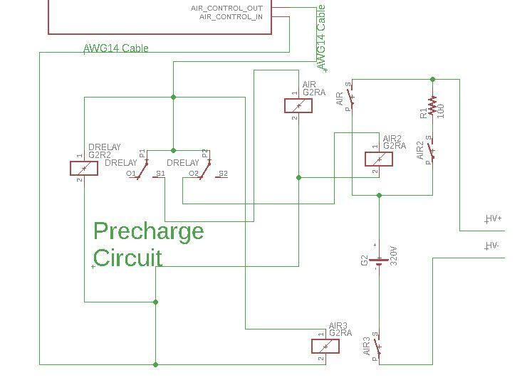

This Precharge circuit using Delay Relay OMRON H3Y-2 that the coil connected to shutdown circuit to control AIRs to open with delay 3000ms to achieve 90% of battery’s voltage. This precharge circuit using 1kOhm resistor, and the the precharge’s graph showed below.

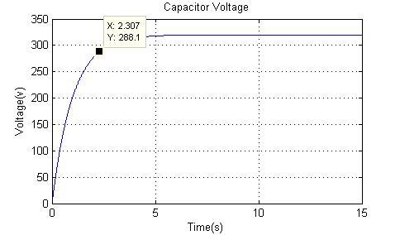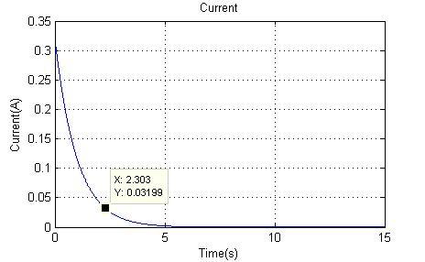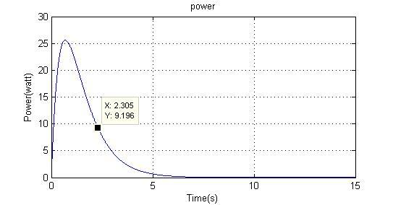

## BMS

### BMS Specifications

The BMS utilized in our design is the Orion BMS from Ewert Energy Systems. This BMS is commercially available and designed specifically for electric and hybrid vehicles. It supports sets of 12 cells up to 108 battery cells or a variety of different battery chemistries. Since we have 30 series groups to monitor, we had to acquire a BMS with a 76 cell or above configuration. It is designed to work in high noise environments and in harsh temperatures ranging from -40 to 80 degrees Celsius. The BMS can read cell voltages from .5 to 5 volts. The accumulator pack consists of lithium ion cells, the maximum cell open circuit voltage limit is set to 4.2 volt and minimum open circuit voltage limit set to 3 volts. Measurement resolution is 1.5mV. The ADC within the AMS has a 12 bit resolution with a ±10mV accuracy rating. If the voltages get near the limits it opens the AIRs. The temperature limit is set to be 60 C and if this temperature is exceeded it opens the AIRs. All the sense wires are electrically and magnetically isolated by the BMS. In the case that an error is detected and the BMS needs to open AIR’s, it switches the internal relay which connects to the internal shutdown circuit.

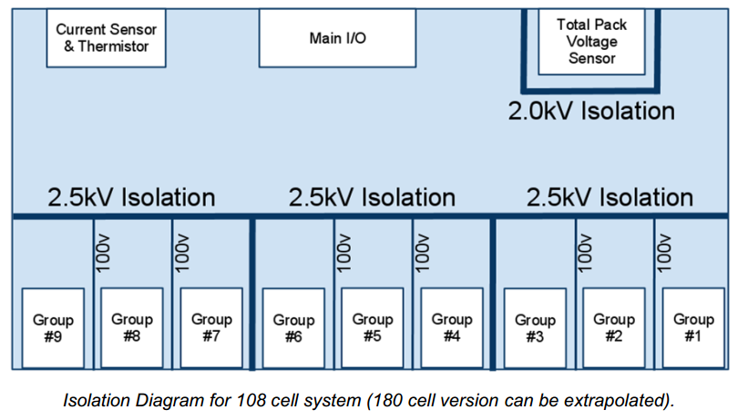

The Orion BMS provides 2.5kV isolation between cell voltage taps and control electronics as well as between groups of 36 cells. The total pack voltage sensor is isolated from all other electronics by 2.0kV DC isolation. Isolation between cell groups 1, 2 and 3 is a nominal 100v isolation which is an ideal placement of high resistance busbars or cables between cells, but cannot be used for a safety disconnect or fuse since it is not rated to withstand the full stack voltage.

NOTE : 108 cell above are diagram on ORION BMS, not amount of cell that we are used.

### Temperature Sensors

|  |  |
| --- | --- |
| Make / Model: | Thermistor 10k |
| Accuracy of sensor: | 1°C |
| Datasheet: | Datasheet |
| # of sensors: | 23 (Accumulator has 76 cell) |
| % of cells sensed: | 30% |

Table ‑ - Temperature Sensor Specifications

### Temperature Sensor Location

The thermal sensor are mounted directly in the inside of the accumulator.

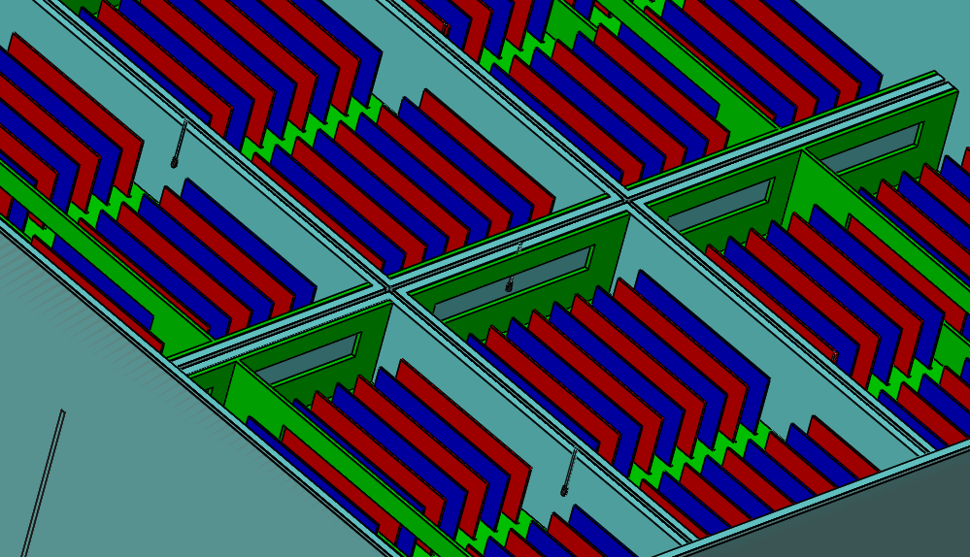

Behind This Separation

Behind This Separation

Figure ‑ - Location of Temperature Sensors

### BMS Voltage Sense Leads

Since we’re using Li-Po KOKAM SLPB78216216H pouch-type battery we using a PCB to route a sense according to the following picture below. All of the sense lead will be gather in one connector to the BMS.

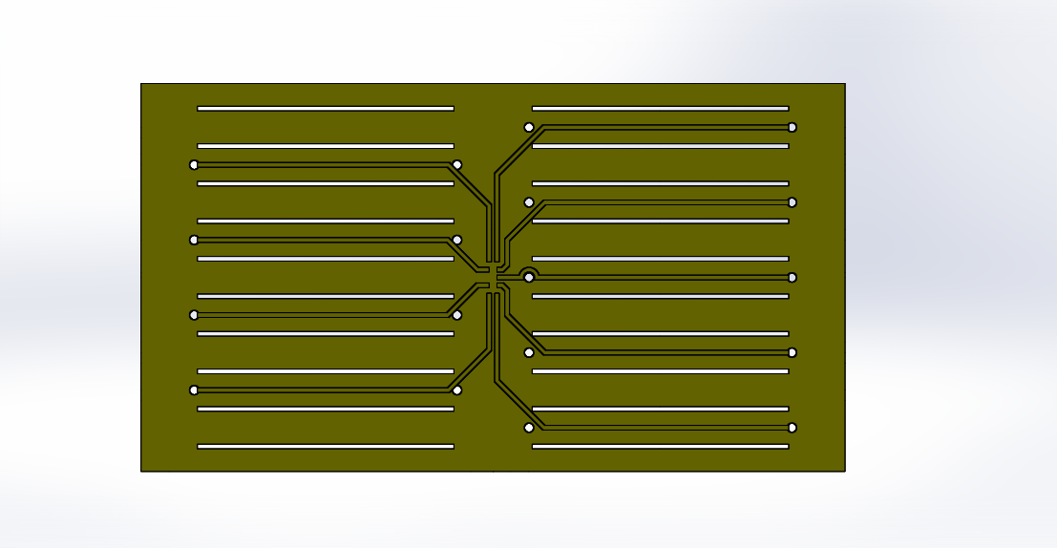



### BMS Voltage Sense Lead Overcurrent Protection

To protect BMS from overcurrent, we use fuse 1A for every connection for voltage sense. When overcurrent is detected, Fuses are going to open circuit and disconnected voltage sense.   
we use a disconnected cable when the overcurrent current exceeds its rating.

### BMS Limits

|  |  |
| --- | --- |
| Max Cell Voltage: | 5 V |
| Min Cell Voltage: | 0.5 V |
| Max Temperature: | 80°C |
| Min Temperature: | -40°C |

Table ‑ - BMS Setpoints

### BMS Location

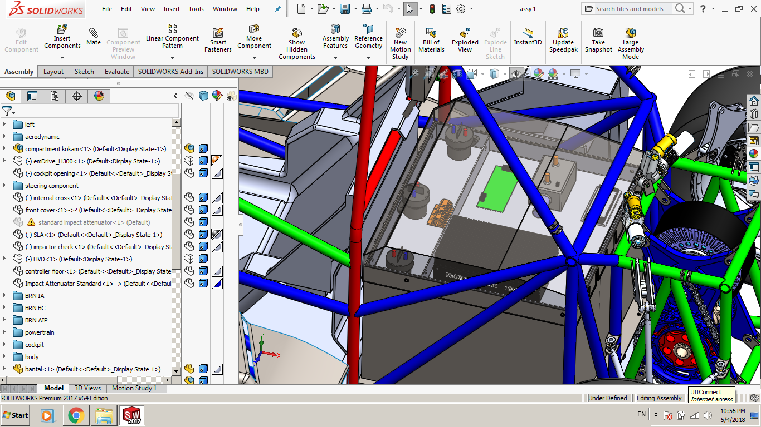

Figure ‑ - BMS Location

## AIR

### AIR Specifications

|  |  |
| --- | --- |
| Make / Model: | Tyco EV200 Contactor 500AMP 320V |
| Contact Current: | 500 A |
| Contact Voltage: | 320 V |
| Datasheet: | Datasheet |

Table ‑- AIR Specifications

## Accumulator Indicator

### Accumulator Indicator Schematic

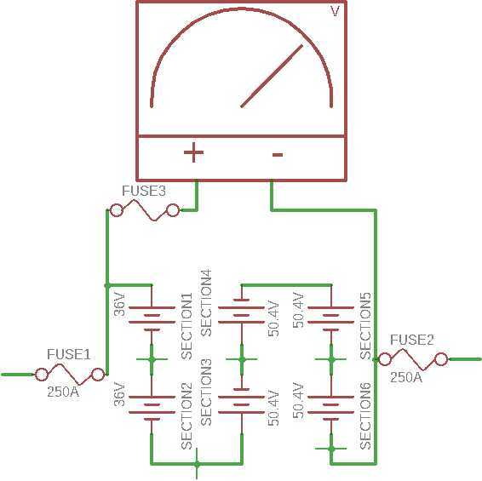

Figure ‑ - Schematic of Accumulator Indication

|  |  |
| --- | --- |
| Product Name | Analog Voltmeter |
| Model No. | 85C1 |
| Measuring Current Range | DC 450 V |
| Accuracy | Classs 2.5 |
| Panel Size | 65 x 56mm/2.6" x 2.2"(L*W) |
| Thread Diameter | 4 mm / 0.16" 3 mm / 0.12" |
| Overall Depth | 60 mm / 2.4" |
| Mount | Vertical |
| Material | Plastic, Electronic Components |
| Color | White |
| Net Weight | 83g |
| Package Content | 1 x Analog Voltmeter |

## Mechanical

### Accumulator Enclosure

Accumulator construction consist of 2mm Iron for outer wall and separator. Layer between segments and around segments use 4mm firewall Glass Fiber Cloth HT 800 .

### AIR and Fuse Separation

These insulation relays and fuse are used between each of the modules and between the negative and positive most battery terminals before the high voltage motor controller distribution busbars.

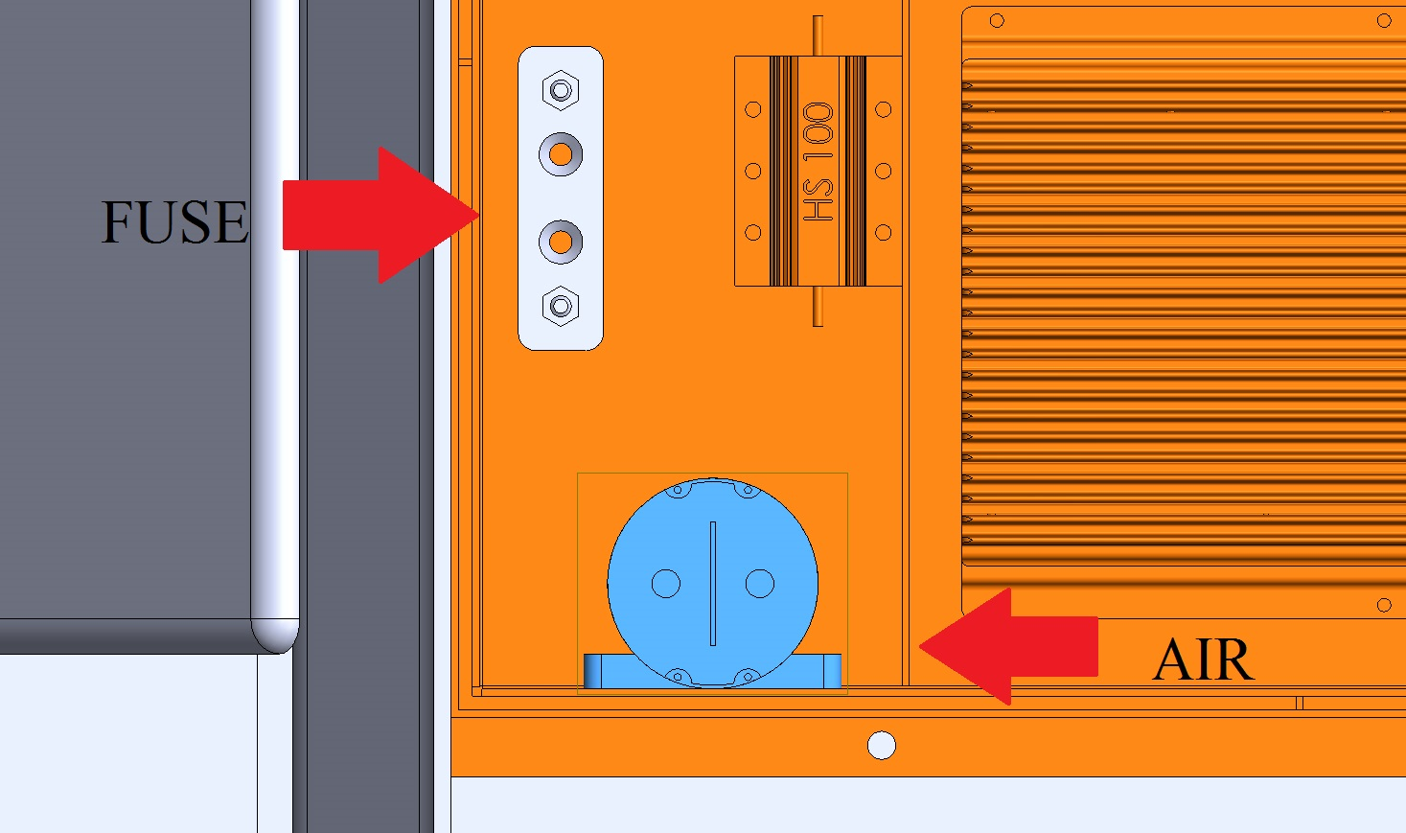

Figure ‑ - AIR and Fuse Separation

## Charging

### Charger Specifications

|  |  |
| --- | --- |
| Make / Model: | Elcon PFC2500 |
| Power: | 25kW |
| Output Voltage: | 336V |
| Output Current: | 7A |
| Input Voltage: | 220VAC |
| Input Current: | 12A |
| Datasheet: | Datasheet |

Table ‑ - Charger Specifications

### Charging Shutdown Circuit

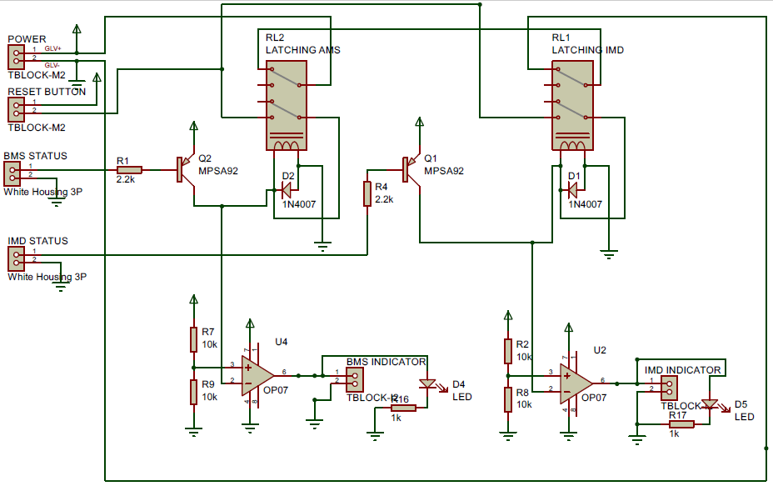

Figure ‑ - Charging Shutdown Circuit Schematic

### Charging TS Circuit

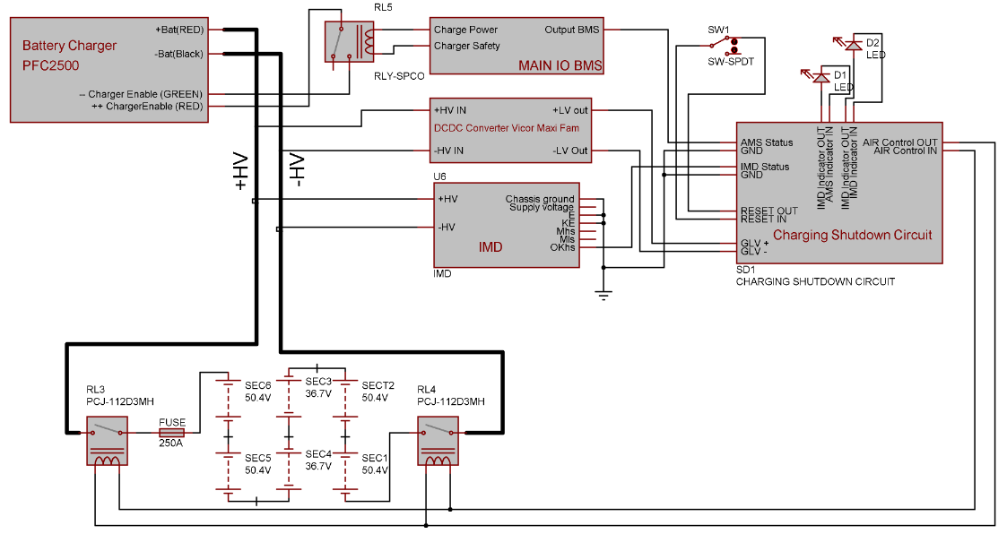

Figure ‑ - Charging TS Schematic

### Charger TS Connection Interlock

We use ELCON PFC2500 as charger, That charger has charging enable control to interlock charging state. Charger TS Connection interlock from circuit above using relay that switch *charger enable* and AIRs that controlled by shutdown circuit. When two pole of *charger enable* is closed, then TS are going to has power and if no fault is detected, then AIRs are going to closed and charging state begin.

### Charger Control

OrionBMS has 2 pin(CHARGER POWER pin and CHARGER SAFETY pin) that is recommended as charging interlock. That pins are going to connected and among them there is a coil to interlock Charger. Normally CHARGER SAFETY pin is turn off and the coil will open switch *charger enable* on charger. When CHARGER SAFETY pin is turn on, then coil will closed and charger is going to working until battery full and CHARGER SAFETY pin is turn off or Fault from BMS or IMD is detected.

### Charger Demonstration

1. Disconnect Motor Controller from Accumulator
2. Connect Accumulator to output of Charger and Charger enable
3. Supply power source to charger
4. Press reset button to remove fault latching
5. Begin to Charge
6. When BMS indicate to stop Charger, remove connection from output of charger and after that remove connection from charger enable
7. Remove from Power source from charger

# Motor Controller

## Controls Architecture/Torque Security

Our EV only use one Motor Controller. Because of it, Our Motor Motor Controller is controlled by APPS. Diagram of Control Architecture is followed by figure below.

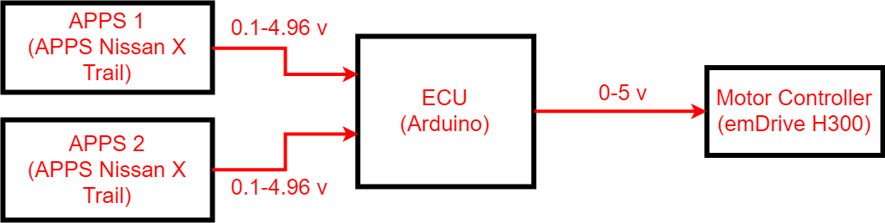

Figure ‑ - Toque Control Signal Path

## Galvanic Isolation

Motor Controller emDrive H300 has insulation protective class I. Galvanic isolation between the tractive system and the grounded low voltage system connections occurs within the motor controller. For more detail isolation is listed below:

* 2.5 kV between control terminals and power terminals
* 2.5 kV between power terminals and case
* 100 V between control terminals and case

# Other Items

## Energy Meter

### Energy Meter Location

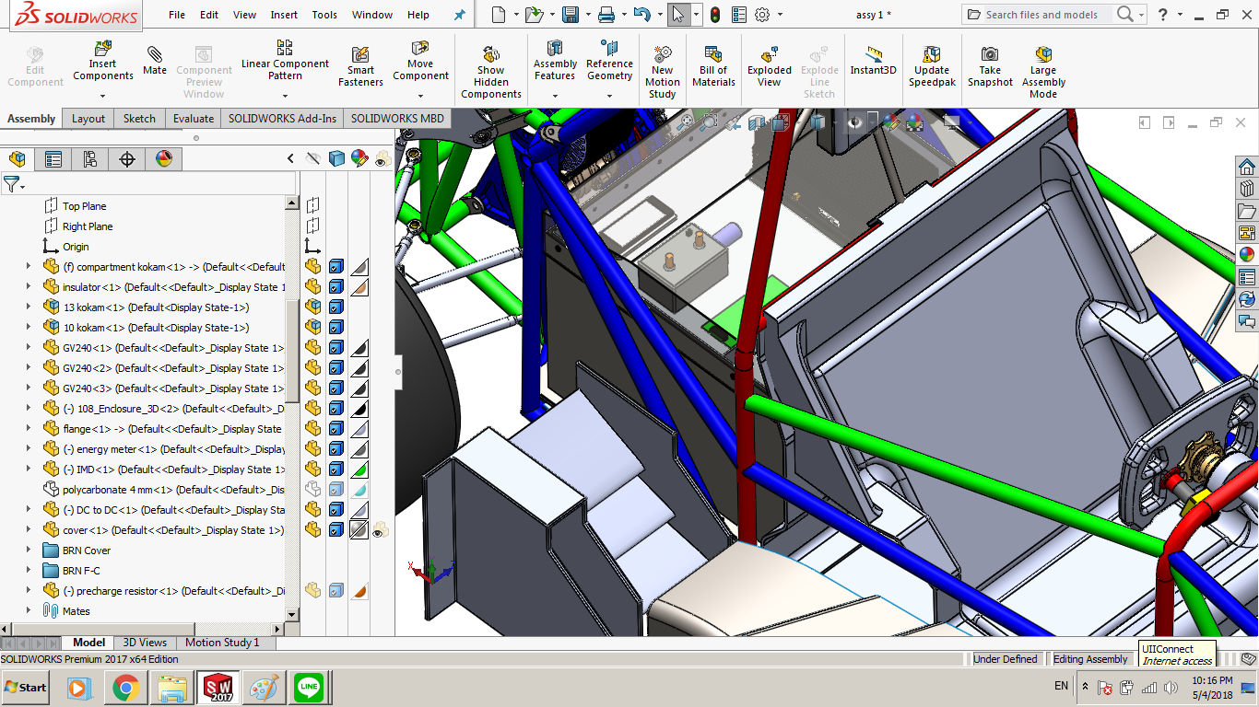

Figure ‑ - Energy Meter Location

### Energy Meter GLV Supply

22 AWG wire is used to connect the energy meter to the LV system that equipped connector Harting 21032122305.

### Energy Meter HV Sense

The energy meter is connected in series on the negative side of the tractive system use 1/0 AWG with lugs and for HV+ sense, use 16 AWG cable that equipped with connector Molex Mini-Fit Jr. 39-01-3022.

## Firewall

### Firewall Layer Specifications

|  |  |
| --- | --- |
| Aluminum layer thickness: | 2mm |
| Insulating layer thickness: | 1 mm |
| Insulating Material Make / Model: | BISCO® HT-800 – Medium Cellular Silicone |
| Insulating Material Datasheet: | Datasheet |
| Insulating Material Video: | [Video](https://drive.google.com/file/d/1AA54lms3xZlJhlxhyvL-lgL0LC4s4POI/view?usp=sharing) |
| Insulating layer side: | Behind Driver |

Table ‑ - Firewall Specifications

### Firewall Location

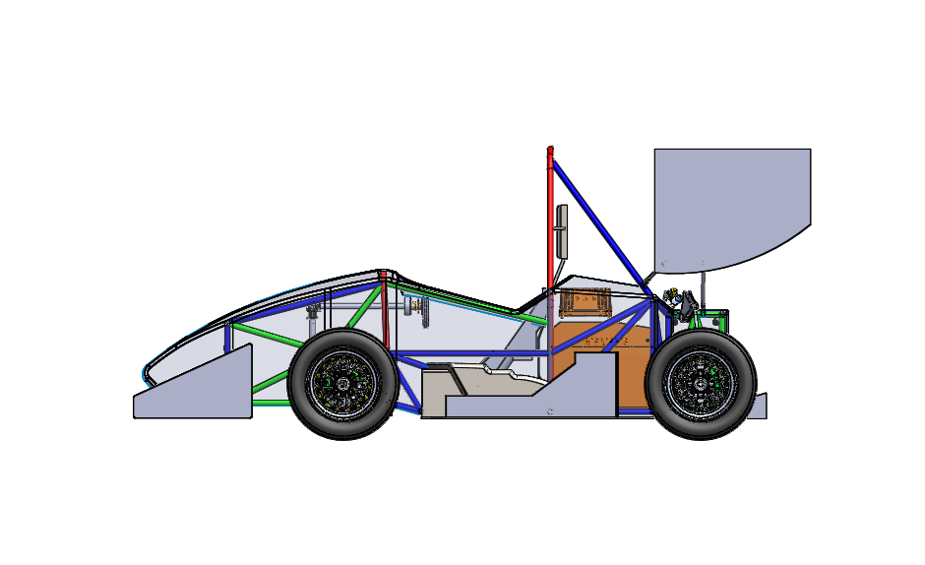

1

2

3

Firewall Location

Figure ‑ - Firewall Location

## Grounding

### Composite Grounding

Grounding will be assambled on chassis. We use 1/0 AWG cable for grounding to GLV. 1/0 AWG cable has 78mOhms per feet.

## Other Components

None additional section to describe

# Appendix

## Kokam SLPB78216216H

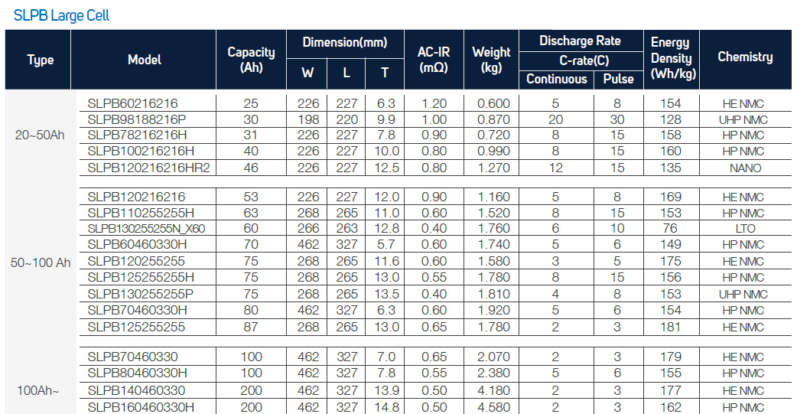

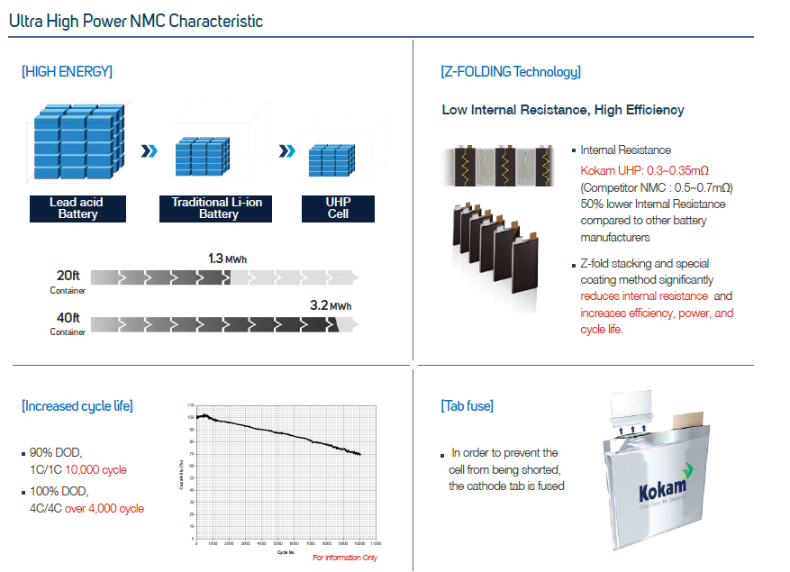

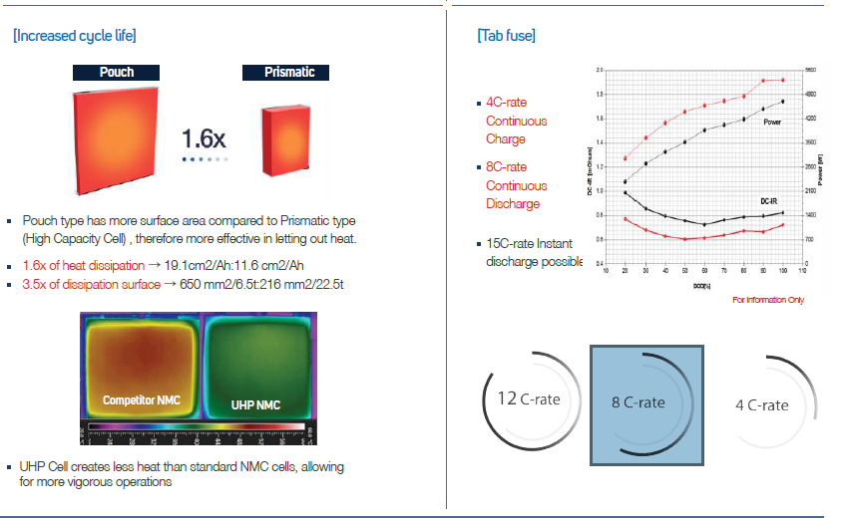

## NYAF cable 70 mm2

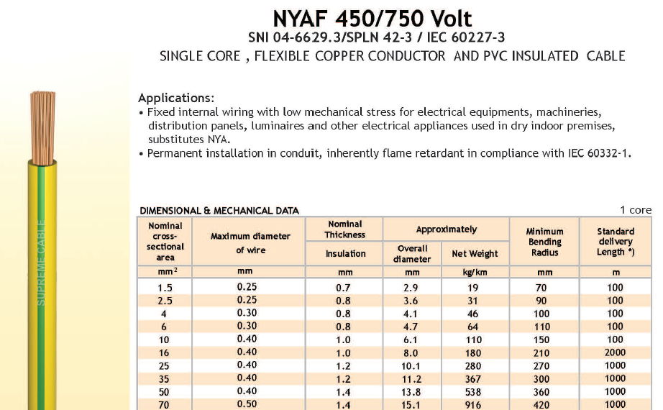

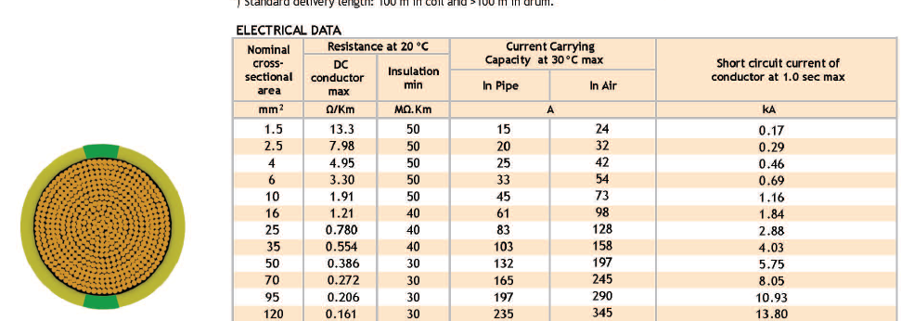

## MOTOR EMRAX 208 LC IP65

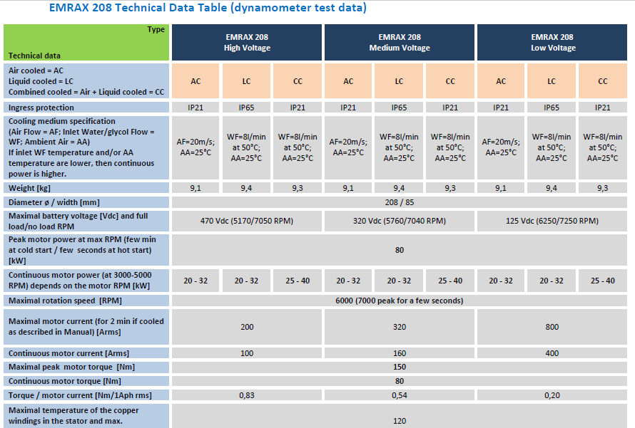

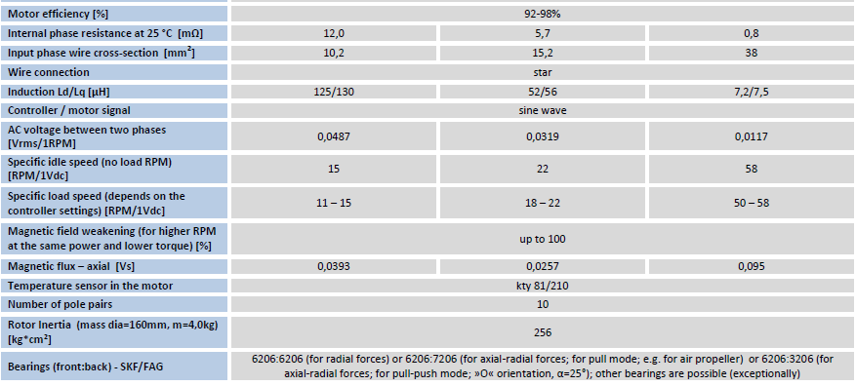

## Model 6387 Banana Jack

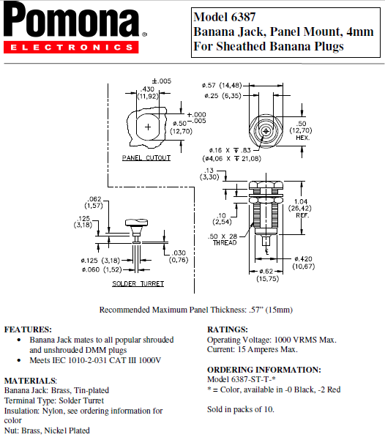

## IMD

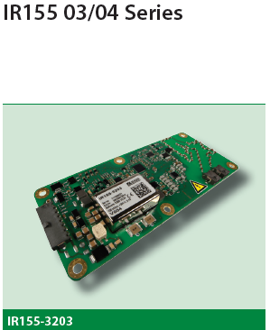

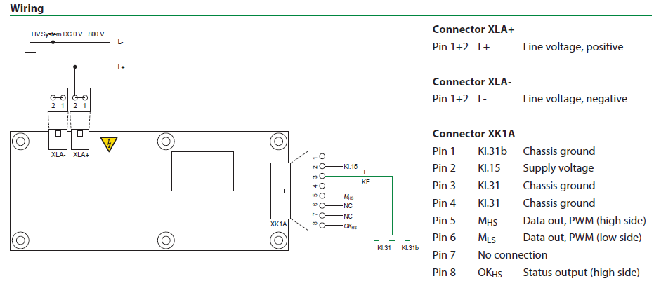

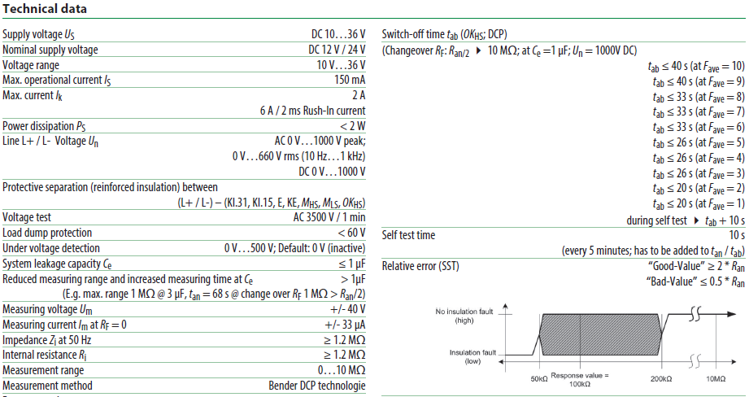

## Potentiometer

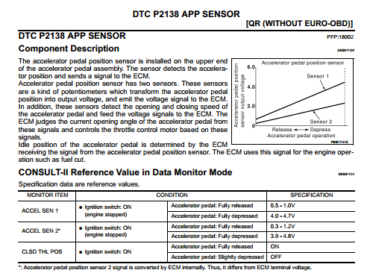

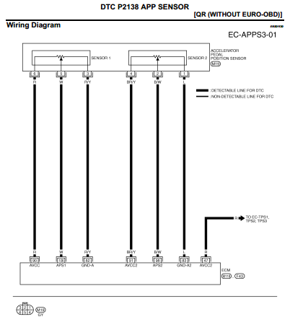

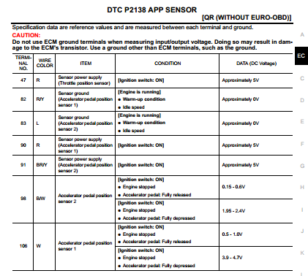

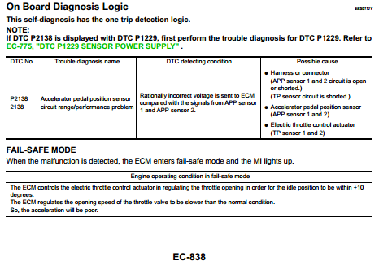

## HVD

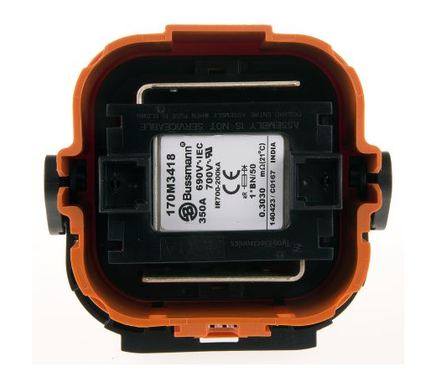

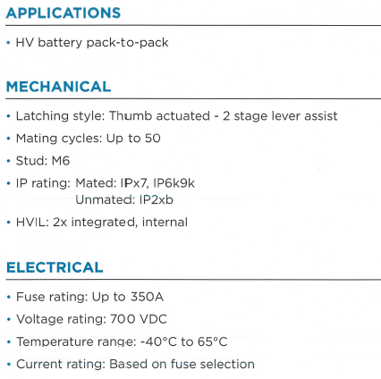

## BMS

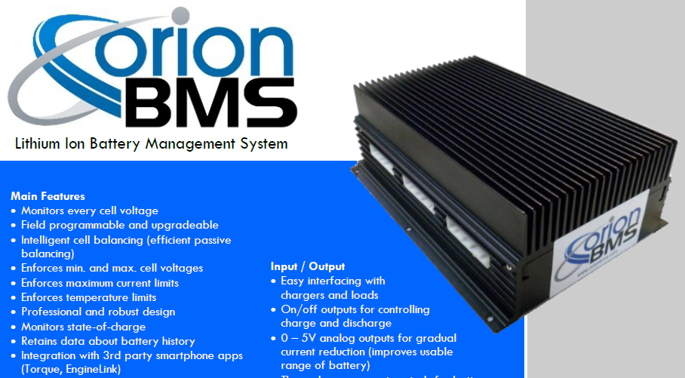

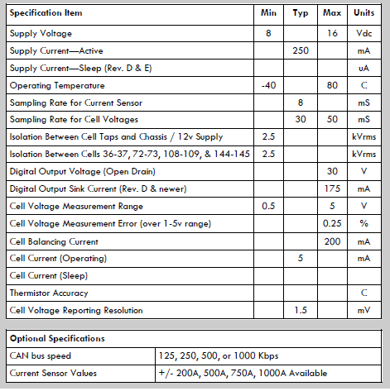

## Fuse L50QS250



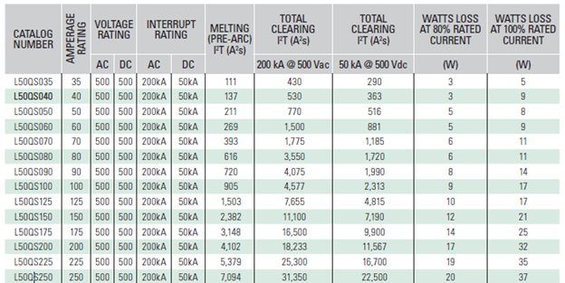

## Buzzer SFM-27-I

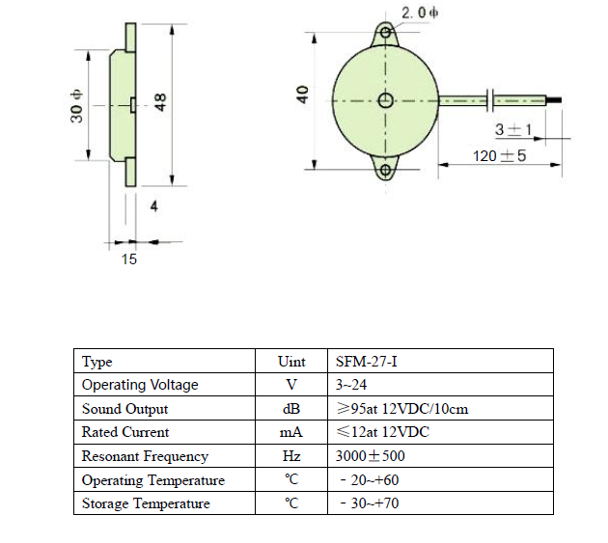

## Delay Relay H3Y-2

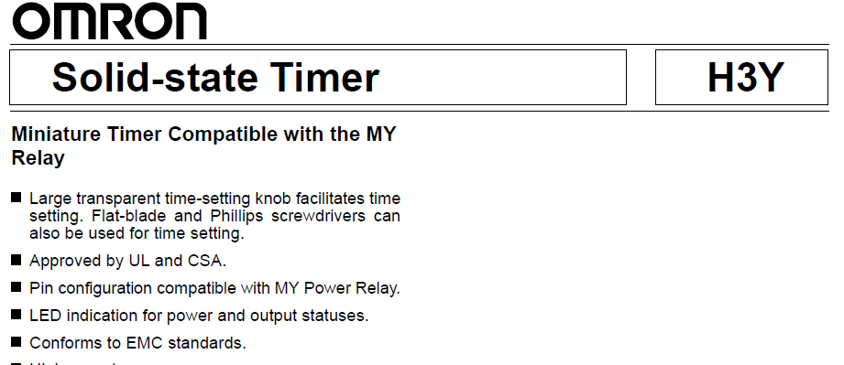

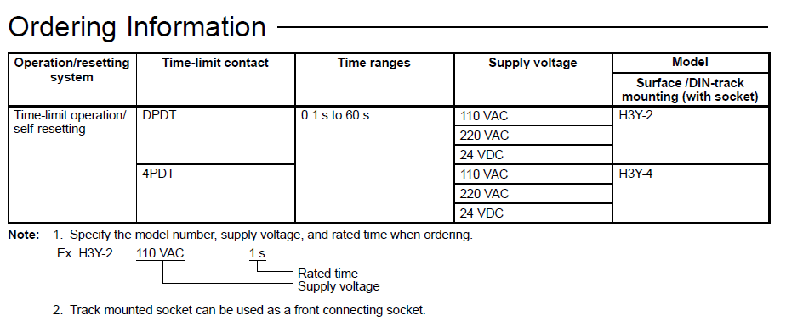

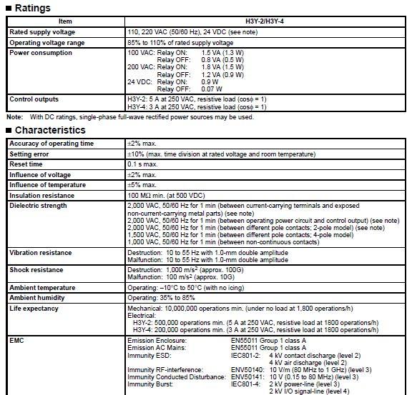

## Thermistor 10K

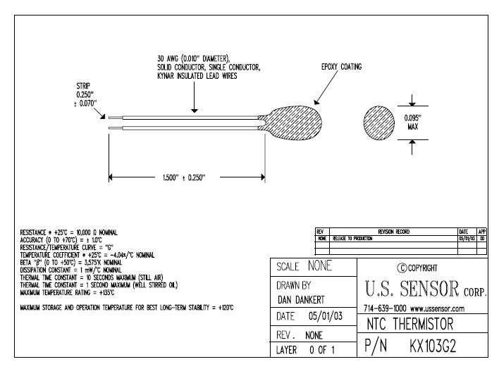

## Tyco EV200 Contactor 500AMP 320V

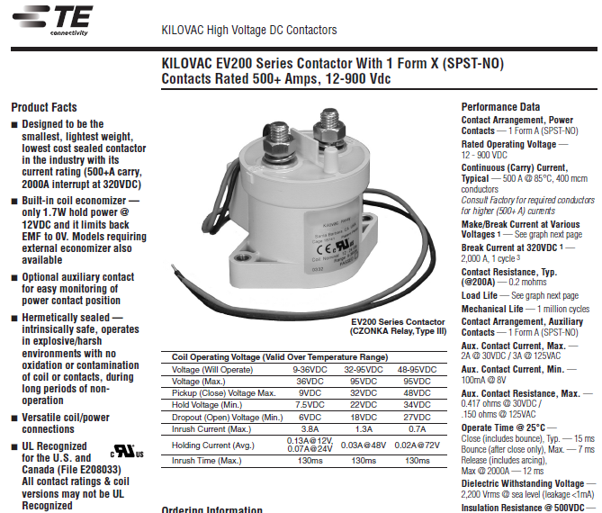

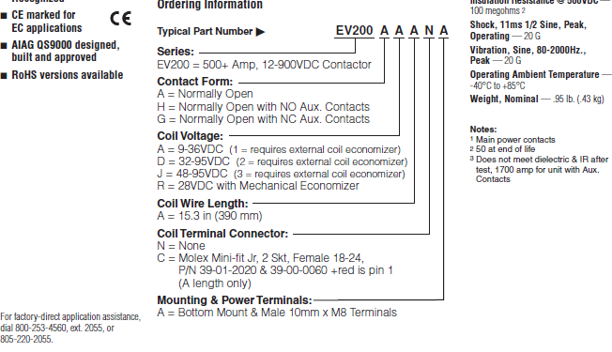

## Firewall

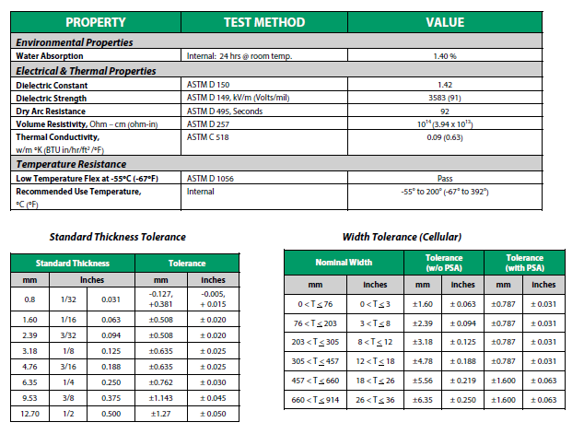

## Current Sensor (L06P400S05)

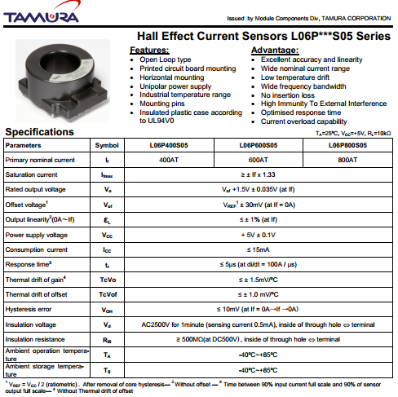

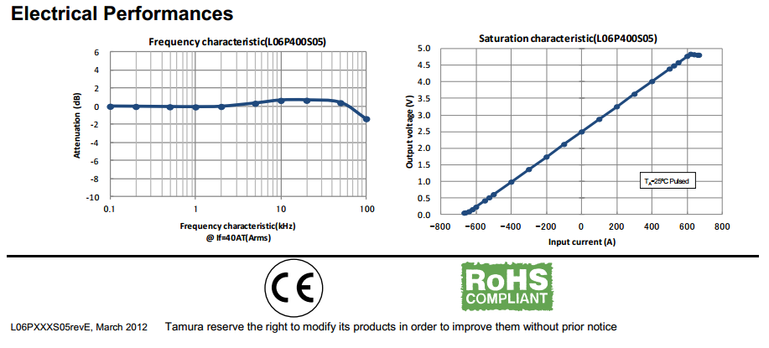

## Precharge and Discharge Resistor

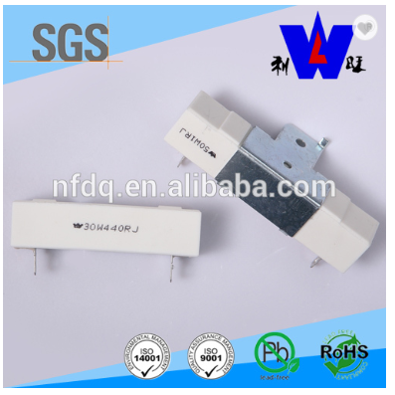

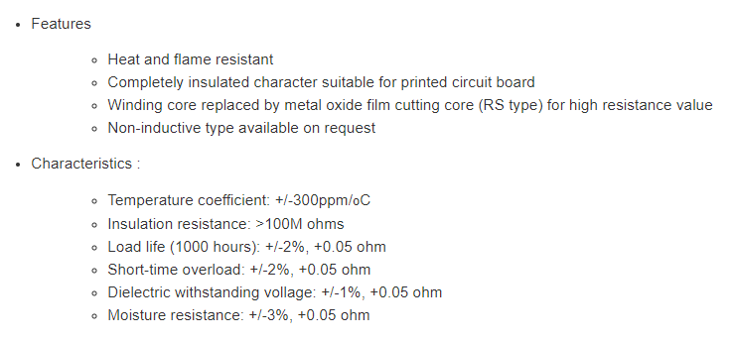

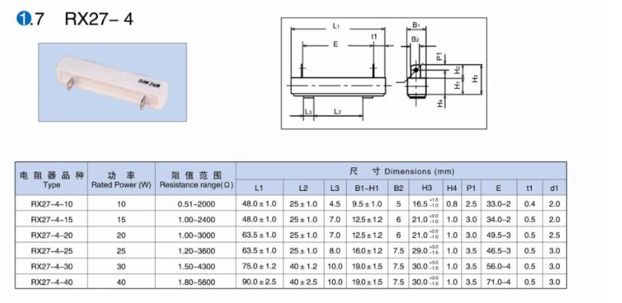

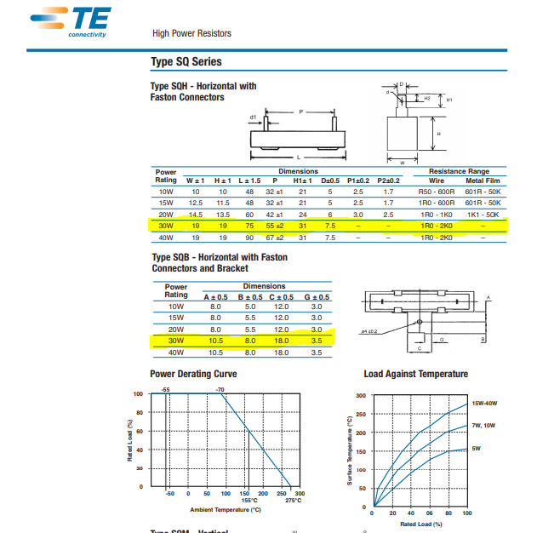

## Resistor for TSMP

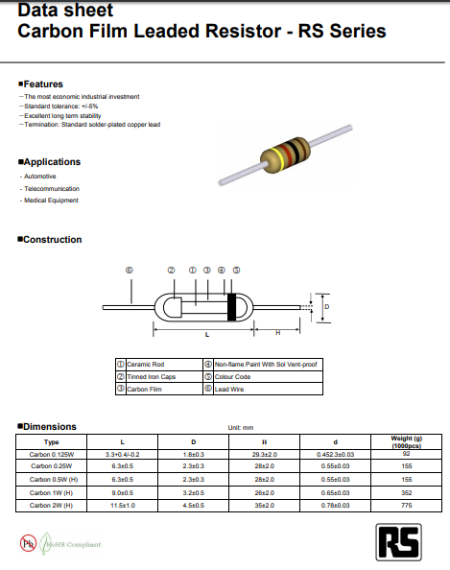

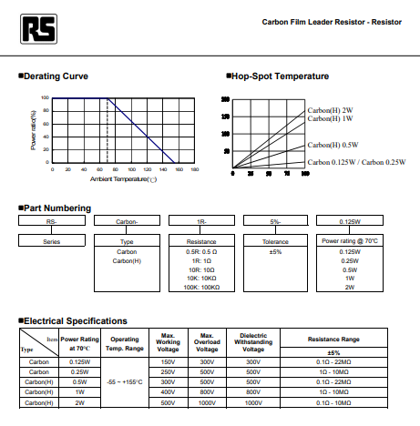

## Charger

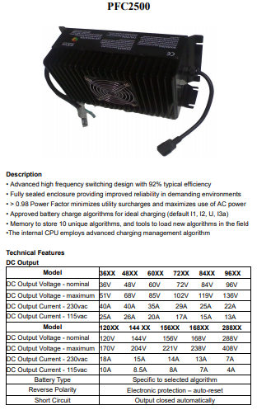

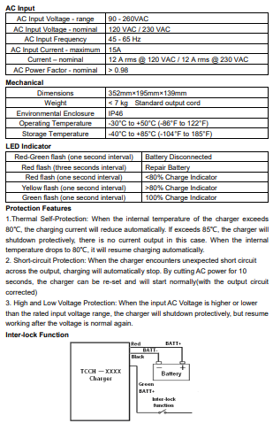

## FUSE SMD 1 A PPTC

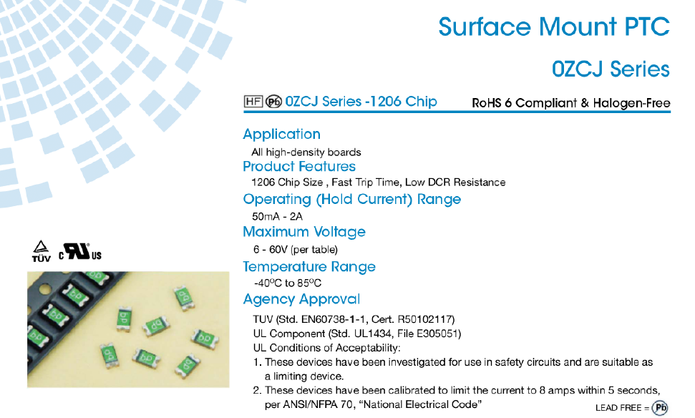

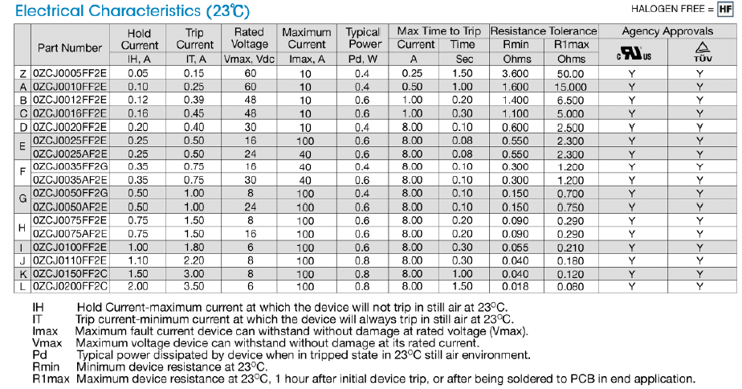

## 20 AWG & 22 AWG CABLE

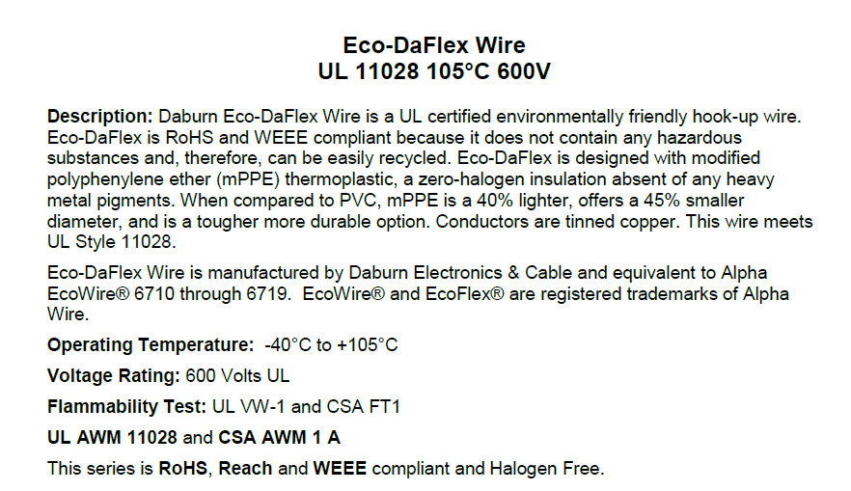

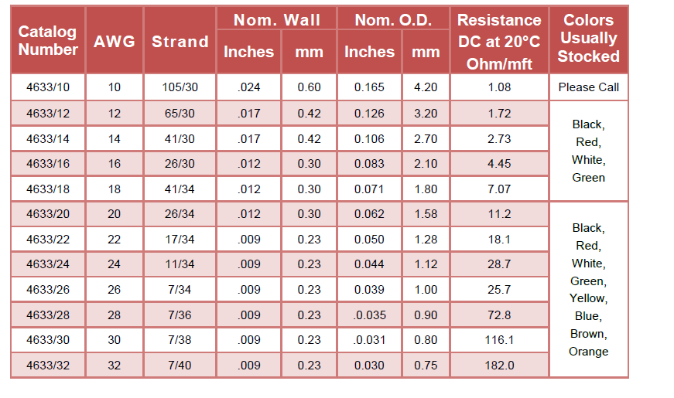

## Amphenol Radlok Connector



